
INDUSTRY REPORT
Retail Trade in the US
Mar 2026

About

IBISWorld
IBISWorld specializes in industry research with coverage on thousands of global industries. Our comprehensive data and in-depth analysis help businesses of all types gain quick and actionable insights on industries around the world. Busy professionals can spend less time researching and preparing for meetings, and more time focused on making strategic business decisions.

Table Of Contents | Standard

1. About 4
Codes 4
Definition 4
Related Terms 4
What's Included 4
Companies 5
Related Industries 5
Additional Resources 5
2. At a Glance 6
Key Takeaways 6
Products and Services 7
Major Players 8
Key External Drivers 9
Industry Structure 9
SWOT 10
Executive Summary 10
3. Performance 12
Highlights 12
Key Takeaways 12
Performance Snapshot 13
Outlook 22
Life Cycle 25
4. Products and Markets 26
Key Takeaways 26
Products and Services 27
Major Markets 32
International Trade 35
5. Geographic Breakdown 36
Key Takeaways 36
Business Locations 37
6. Competitive Forces 42
Key Takeaways 42
Concentration 42
Barriers to Entry 44
Substitutes 45
Buyer & Supplier Power 46
7. Companies 48
Key Takeaways 48
Market Share 49
Companies 50
8. External Environment 55
Key Takeaways 55
External Drivers 55
Regulation & Policy 59
Assistance 61
9. Financial Benchmarks 62
Key Takeaways 62
Cost Structure 62
Key Ratios 65
10. Key Statistics 67
Industry Data 67

1. About
https://my.ibisworld.com/us/en/industry/44-45/about

Codes
NAICS 2017 - USA | 44-45
NAICS 2022 - USA | 44-45

Definition
The retail trade sector is the final step in merchandise distribution and includes retailers operating brick-and-mortar locations and e-commerce platforms. Merchandise sold by retailers is purchased from suppliers and is then sold to consumers through the retailers’ stores or other mediums. This sector excludes the physical manufacture of merchandise and businesses that primarily trade as wholesalers.

Related Terms

POINT-OF-SALE SYSTEM
A hardware or software system that traces where a transaction occurs at a retail establishment or store.

HOMOGENEOUS GOODS
Items that are similar among retailers, with little or no differentiation.

RADIO-FREQUENCY IDENTIFICATION
A technology that tracks products from the time they leave the assembly line to the time they leave the store by releasing continuous signals from a chip.

MASS MERCHANDISER
A large retail store that offers a wide range of product categories.

What's Included
- Motor vehicle and parts dealers
- Furniture and home furnishings stores
- Health and personal care stores
- Building materials and garden equipment and supplies dealers
- Food and beverage stores
- Gasoline stations
- Clothing and clothing accessories stores
- Sporting goods, hobby, book and music stores
- General merchandise stores

Companies
- Walmart Inc.

Related Industries

Industries in the Same Sector
- Competitors:
  - Wholesale Trade in the US
- Complementors:
  - Manufacturing in the US

International Industries
- Global Automobile & Light-Duty Motor Vehicle Sales
- New Car Dealers in Canada
- Furniture Stores in Canada
- Supermarkets & Grocery Stores in Canada

Additional Resources
- National Retail Federation
- Retail Industry Leaders Association
- National Grocers Association
- National Automobile Dealers Association
- ERA Global Electronic Retailers Association
- US Census Bureau

2. At a Glance
https://my.ibisworld.com/us/en/industry/44-45/at-a-glance
Revenue  $7.6tr  ’21-’26 ↓ 0.0 %  ’26-’31 ↑ 2.1 % | Employees  18m  ’21-’26 ↑ 0.6 %  ’26-’31 ↑ 1.7 % | Businesses  3m  ’21-’26 ↓ 0.9 %  ’26-’31 ↑ 1.1 %
Profit  $696.4bn  ’21-’26 ↑ 1.6 % | Profit Margin  9.2%  ’21-’26 ↑ 0.7 pp | Wages  $662.3bn  ’21-’26 ↑ 0.3 %  ’26-’31 ↑ 1.8 %

Key Takeaways

Performance
- Consumer confidence is bouncing back, driving retail spending. As inflation cools and interest rates become more predictable, shoppers splurge on everything from furniture to luxury goods, promising a lucrative upswing for the retail sector.
- E-commerce and omnichannel strategies drive retail growth. With Gen Z and millennials leaning heavily toward online shopping, retailers blend digital and physical experiences to boost engagement and loyalty.
- AI is revolutionizing retail operations. AI helps retailers minimize waste, cut costs and boost customer satisfaction by predicting buying trends, optimizing logistics and enhancing security. These abilities give AI-savvy retailers a competitive edge in a crowded market.

Products and Markets
- Motor vehicle and parts dealers lead in sales due to their high-ticket nature and adaptability. Auto dealers that offer a mix of new and used vehicles can navigate economic fluctuations with more agility and tap into diverse consumer needs.
- Consumers aged 45 to 64 are retail heavyweights, i.e. they tend to purchase big-ticket luxury items. Yet with their typically sizeable disposable income, they prioritize quality and convenience, giving retailers opportunities to enhance profit through premium offerings.
- Health and personal care stores are thriving, driven by an growing population that is of advanced age and heightened health consciousness across demographics. With a significant sales surge since 2021, these stores are capitalizing on consumers’ rising prioritization of health-related purchases.

Products and Services
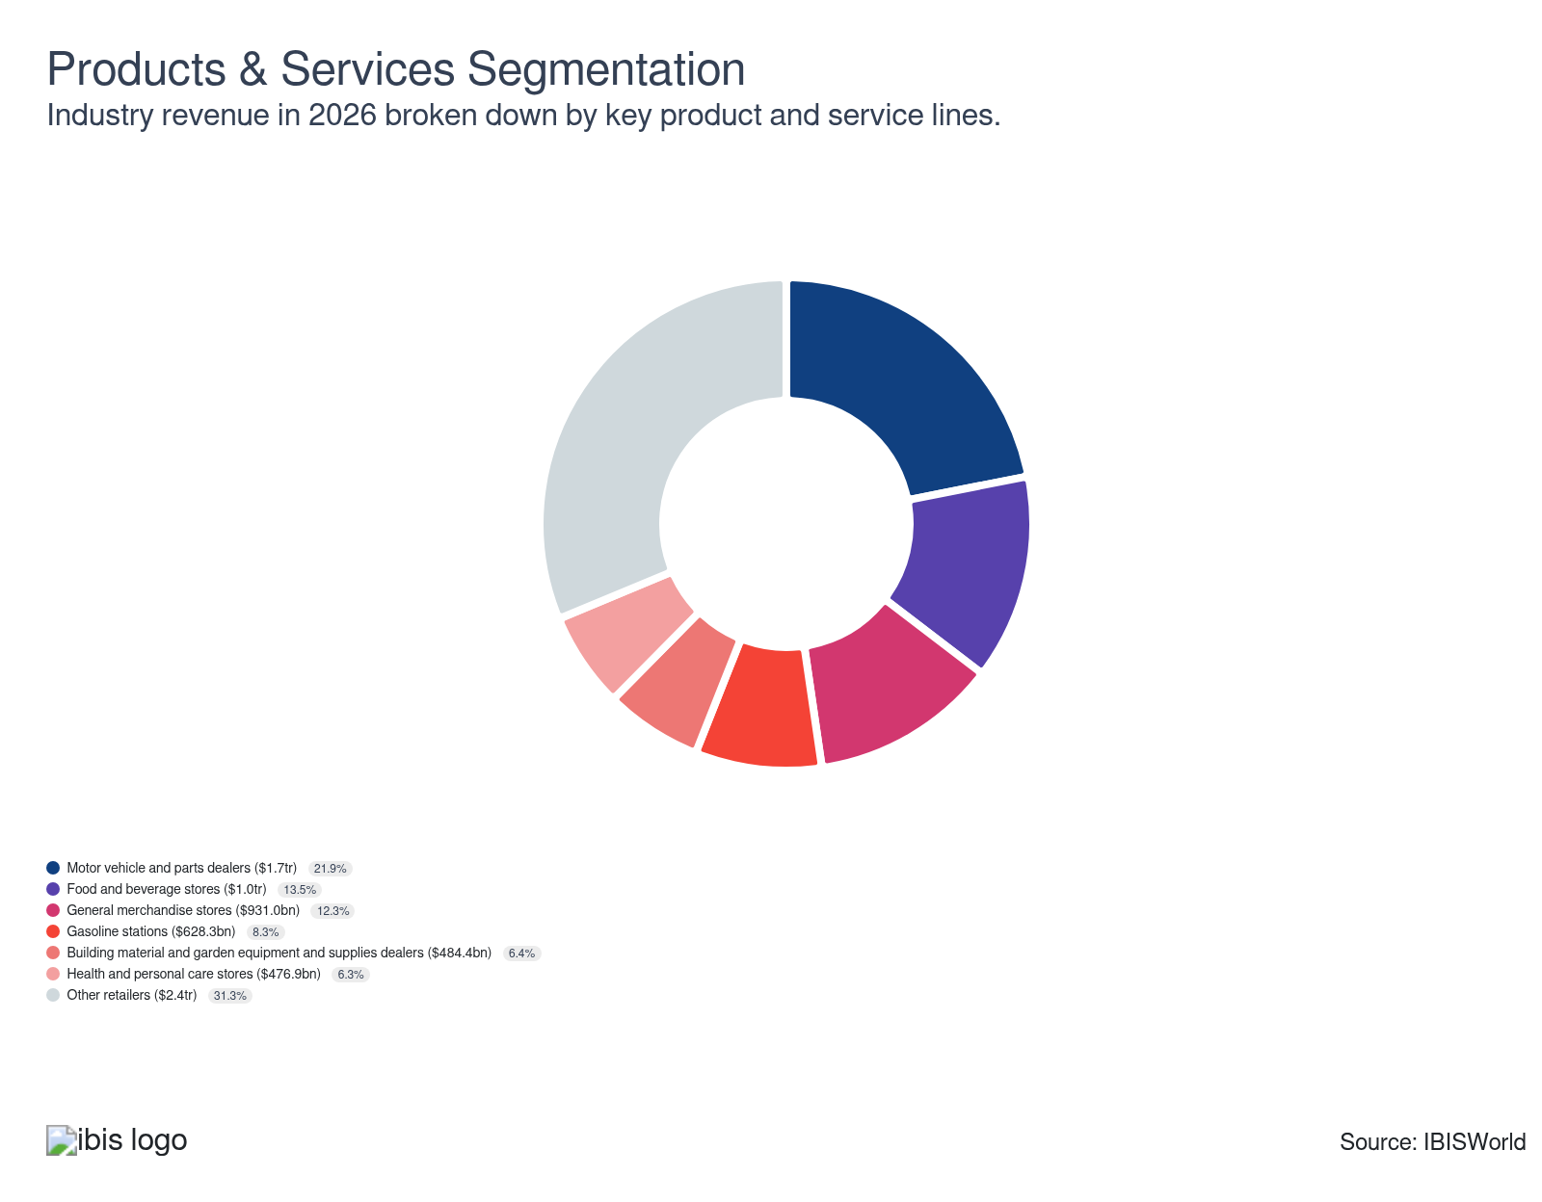

Major Players
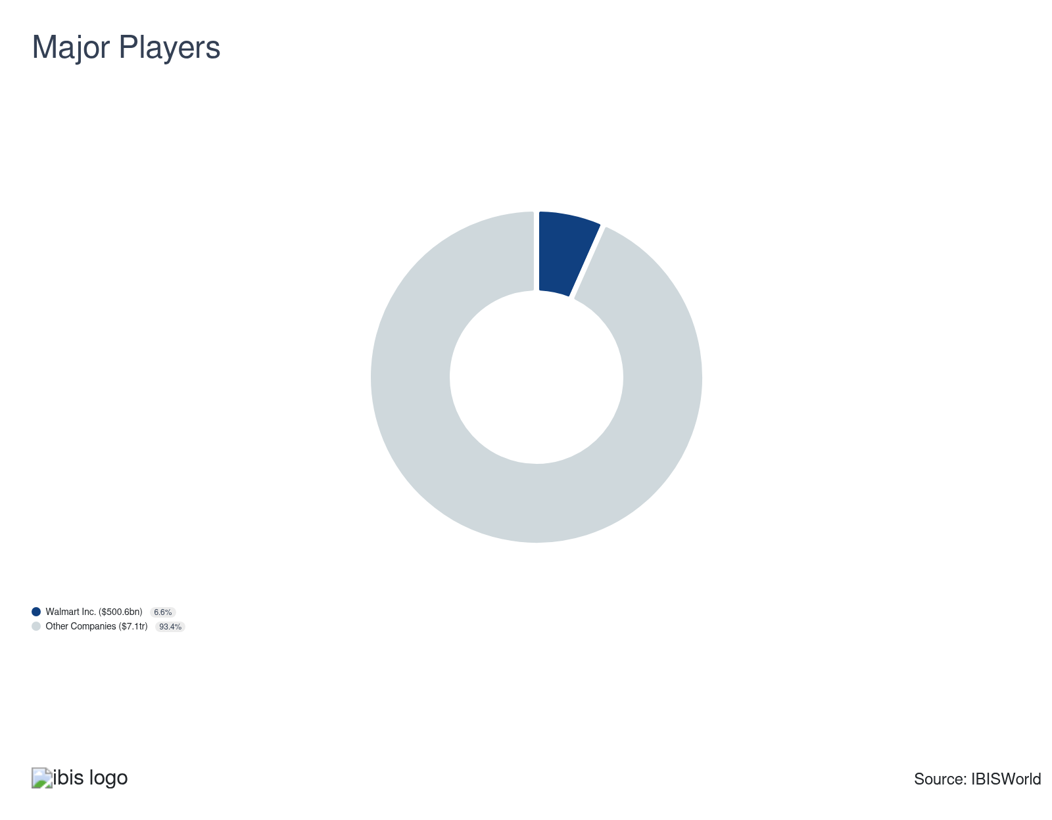

Key External Drivers
Key External Drivers | Impact
Per capita disposable income | Positive
Consumer spending | Positive
Agricultural price index | Positive
Price of electric power | Negative
E-commerce sales | Positive
National unemployment rate | Negative

Industry Structure
Characteristic | Level | Trend
Concentration | Low
Barriers To Entry | Low | Steady
Regulation and Policy | Moderate | Steady
Life Cycle | Mature
Revenue Volatility | Moderate
Assistance | Low | Steady
Competition | High | Increasing
Innovation | Moderate

SWOT
Strengths  High Profit vs. Sector Average  Low Customer Class Concentration  Low Product/Service Concentration  High Revenue per Employee | Weaknesses  High Capital Requirements | Opportunities  High Revenue Growth (2021-2026)  High Revenue Growth (2026-2031)  High Performance Drivers  E-commerce sales | Threats  Low Revenue Growth (2005-2026)  Low Outlier Growth  Consumer spending

Executive Summary

Shopping spree: Rising per capita disposable income is expected to support industry growth
The Retail Trade sector in 2026 is showing cautious but promising signs of recovery after years of stagnation. Industry revenue will climb an estimated 0.9% this year to reach $7.6 trillion, breaking from a flat five-year CAGR of 0.0%. Strong e-commerce adoption and omnichannel strategies are propelling the sector's rebound, blending digital convenience with in-person experience. Retailers like Sephora and Lululemon have aligned with shifting consumer behavior—particularly among younger, tech-driven demographics—through virtual try-ons, in-store events and app-based loyalty initiatives. Automation is also reshaping operations, from self-checkout systems to inventory management, allowing retailers to control costs while delivering faster and more personalized service. Against this backdrop, sustainability pressures from eco-conscious consumers are prompting businesses to rework product lines and adopt greener supply chain practices, creating new value streams through resale markets and reverse logistics.
Over the past five years, from 2021 to 2026, the retail sector has undergone significant transformations driven by technological acceleration, shifting consumer preferences and macroeconomic volatility. Despite nearly stagnant revenue growth, profitability has held steady due to cost optimization and diversification strategies. Retailers expanded into new categories—such as grocery, healthcare and wellness—to insulate operations from cyclical downturns and maintain steady traffic. Meanwhile, e-commerce penetration surged, with online sales up 16.2% since 2021, reinforcing digital as the cornerstone of growth. Automation and data-driven decision-making helped retailers remain resilient despite supply chain disruptions and tight labor markets. Sustainability also emerged as a competitive differentiator, with major companies investing in transparency, circularity and energy efficiency to attract ethically driven consumers, particularly Gen Z and millennials, who are dominating purchase influence.
Looking ahead, retail sales are forecast to rally at a 2.1% CAGR through 2031, reaching $8.4 trillion. Artificial intelligence will play a defining role—refining pricing, forecasting demand and personalizing shopping experiences across channels. Extended reality tools like augmented and virtual reality will further integrate digital engagement with physical retail to enhance immersion and loyalty. However, growth will unfold in a tempered economic climate marked by modest income gains, cautious consumer sentiment and ongoing trade policy uncertainty. Retailers that deliver transparency, value and consistent omnichannel convenience will lead the field, while those slow to integrate AI, automation and sustainability may lag. Ultimately, sustained innovation and strategic flexibility will determine which brands thrive in this evolving landscape, as technology and ethics converge to redefine the modern retail experience.

3. Performance
https://my.ibisworld.com/us/en/industry/44-45/performance

Highlights
Revenue  $7.6tr  2021-26 CAGR ↓ 0.0 %  2026-31 CAGR ↑ 2.1 % | Employees  18m  2021-26 CAGR ↑ 0.6 %  2026-31 CAGR ↑ 1.7 % | Businesses  3m  2021-26 CAGR ↓ 0.9 %  2026-31 CAGR ↑ 1.1 %
Profit  $696.4bn  2021-26 CAGR ↑ 1.6 % | Profit Margin  9.2%  2021-26 CAGR ↑ 0.7 pp

Key Takeaways
- Consumer confidence is bouncing back, driving retail spending. As inflation cools and interest rates become more predictable, shoppers splurge on everything from furniture to luxury goods, promising a lucrative upswing for the retail sector.
- E-commerce and omnichannel strategies drive retail growth. With Gen Z and millennials leaning heavily toward online shopping, retailers blend digital and physical experiences to boost engagement and loyalty.
- AI is revolutionizing retail operations. AI helps retailers minimize waste, cut costs and boost customer satisfaction by predicting buying trends, optimizing logistics and enhancing security. These abilities give AI-savvy retailers a competitive edge in a crowded market.

Performance Snapshot
Revenue: | ↓ 2021-26 Revenue CAGR 0.0%
Revenue  $7.6tr  ’21-’26 ↓ 0.0 %  ’26-’31 ↑ 2.1 % | 2026 Revenue Growth  ↑ 0.9 % | Revenue Volatility  Moderate
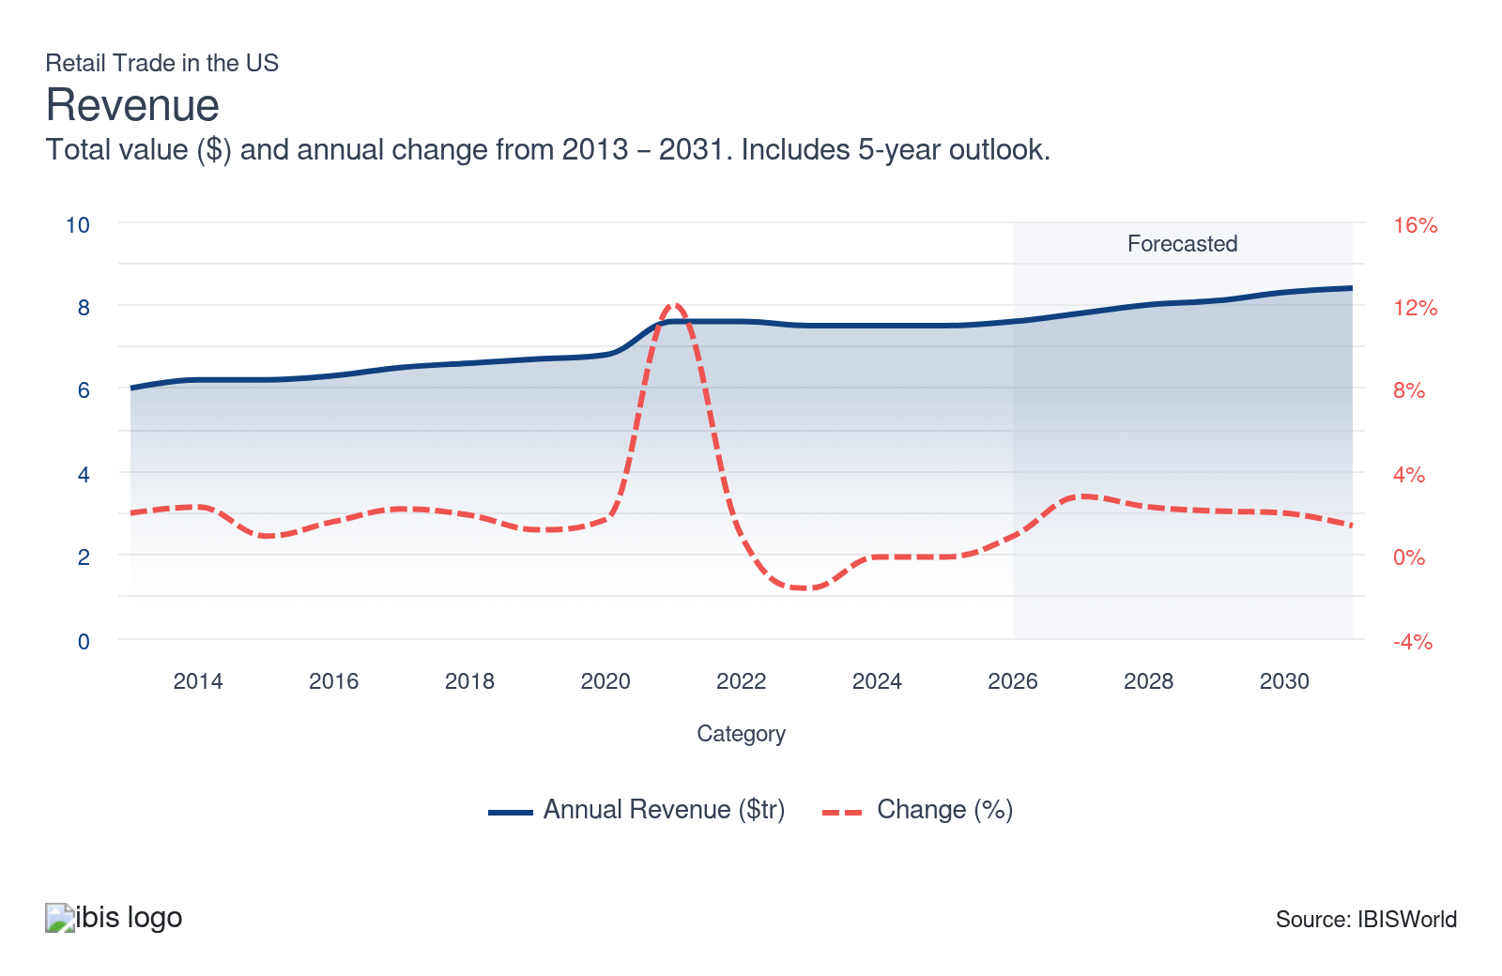
Employees: | ↑ 2021-26 Employees CAGR +0.6%
Employees  18m  ’21-’26 ↑ 0.6 %  ’26-’31 ↑ 1.7 % | Employees per Business  6  ’21-’26 ↑ 1.5 %  ’26-’31 ↑ 0.6 % | Revenue per Employee  $411k  ’21-’26 ↓ 0.6 %  ’26-’31 ↑ 0.4 %
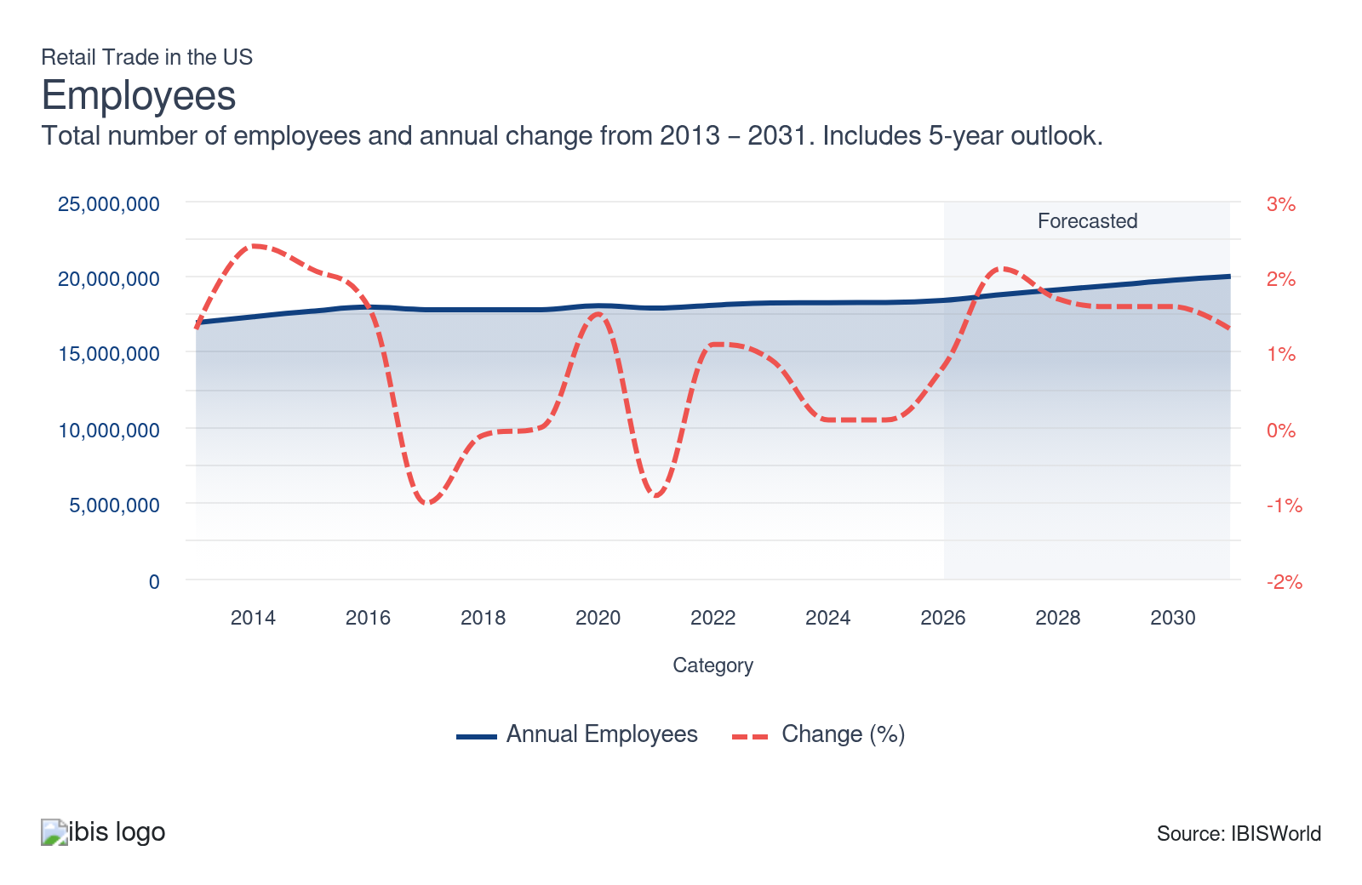
Businesses: | ↓ 2021-26 Business CAGR -0.9%
Businesses  3m  ’21-’26 ↓ 0.9 %  ’26-’31 ↑ 1.1 % | Employees per Business  6  ’21-’26 ↑ 1.5 %  ’26-’31 ↑ 0.6 % | Revenue per Business  $2.6m  ’21-’26 ↑ 0.9 %  ’26-’31 ↑ 1.0 %
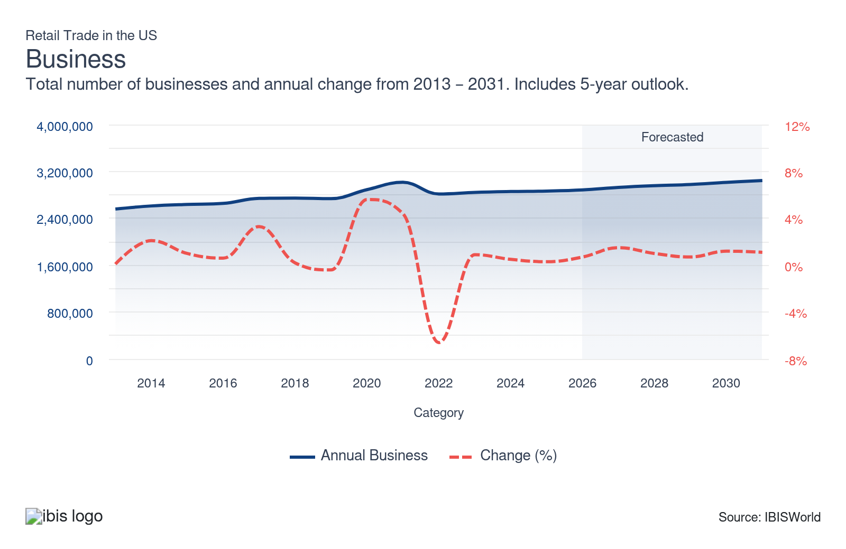
Profit: | ↑ 2021-26 Profit CAGR +1.6%
Total Profit  $696.4bn  ’21-’26 ↑ 1.6 % | Profit Margin  9.2%  ’21-’26 ↑ 0.7 pp | Profit per Business  $241.3k
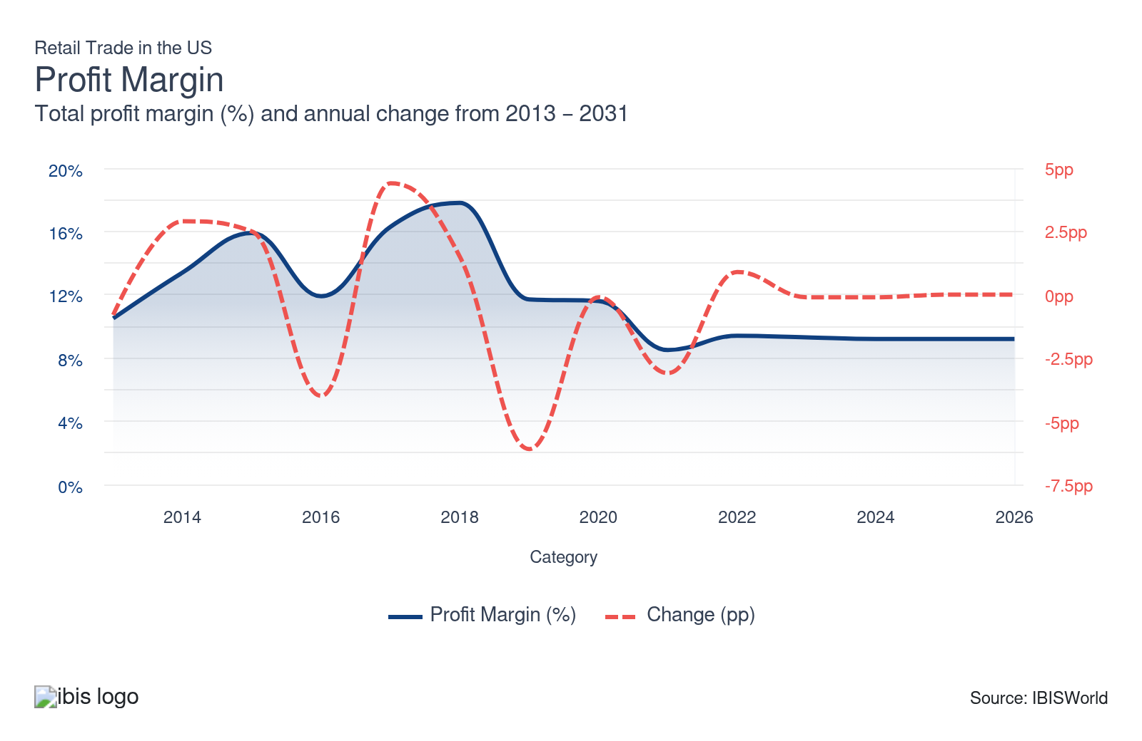
Current Performance
Current Performance

What's driving current industry performance?

Retailers double down on omnichannel strategies to capture online-first spending power
- E-commerce’s boom has significantly reshaped the retail sector since the pandemic, driven by increased activity among Gen Z and millennials in particular. 16.2% online sales growth since 2021 highlights the consistent upward trajectory for retailers in digital shopping. A survey by consumer behavior research firm GWI indicates that 56.0% of Gen Z prefer online shopping. This cohort’s digital preference has compelled retailers to focus more on digital platforms.
- Retailers like Sephora have effectively implemented omnichannel strategies through options like the Virtual Artist app, which enables consumers to try on makeup virtually while also receiving offers redeemable in-store. This integration boosts customer engagement and enhances brand loyalty by offering novel and personalized shopping experiences.
- Brick-and-mortar stores create in-store experiences to draw customers in and thereby remain relevant, in some cases tapping into foot traffic for customer acquisition. Initiatives like Lululemon’s run clubs exemplify the connections physical stores cultivate with customers. These experiences strengthen the customer’s relationship with the brand in person by encouraging more frequent, longer visits that purely digital storefronts can’t match.
- As digital privacy laws have tightened in recent years, retailers have focused on in-store marketing tactics. For instance, as of 2023, Walmart rolled out around 170,000 in-store digital screens and began emulating Costco in its use of free samples to engage consumers directly and offset the challenges of online data collection.
- Honing omnichannel approaches to ensure that online and physical shopping experiences complement each other will help retailers capitalize on the ever-growing digital trend for both environments. Incorporating flexibility and personalization into these efforts will drive revenue growth.

Automation helps streamline operations and sharpen competitiveness
- Automation has become a defining force in retail, driven by the sector’s need to cut costs, improve operational efficiency and meet rising consumer expectations for faster, more personalized service. Retail automation spans technologies such as self-checkout systems, inventory management software and data-driven marketing tools, all designed to streamline the customer experience and business operations.
- Self-checkout systems are among the most visible signs of this shift. In 2023, stores installed more than 217,000 self-checkout terminals worldwide, according to RBR Data Services—a 12.0% rise from the previous year—demonstrating retailers’ widespread move toward faster, lower-friction transactions. These systems reduce dependency on human cashiers, minimize transaction errors and enhance overall customer satisfaction.
- Behind the scenes, automated inventory management has tightened supply chains, aligning stock levels more closely with consumer purchases. This optimization cuts carrying costs and waste, directly lifting potential earnings. Meanwhile, marketing automation enables retailers to harness customer data for targeted campaigns, improving engagement and conversion rates by tailoring communications to shoppers’ preferences and habits.
- For smaller retailers facing heavy competition from big-box stores, automation offers a critical edge. By reallocating staff to higher-value roles like personalized service, they’re blending the efficiency of technology with the human touch that builds lasting loyalty—positioning automation as both a cost-saving tool and a catalyst for smarter, more competitive retail strategies.

Diversifying product offerings to meet shifting consumer needs stabilizes growth
- Retailers have faced significant challenges over the last five years, including economic fluctuations during and after the pandemic and shifts in consumer behavior. Some companies have weathered these headwinds by offering a wider product range, which helps attract a broader customer base and drive growth.
- Stores like Target and Walmart, for example, sought to enhance the shopping experience for necessities by positioning their spaces to cater to diverse needs, including groceries, clothing, pet care, electronics and healthcare. According to Target, food and beverage sales totaled $24 billion as of August 2024, but the category accounted for only 23.0% of the company’s offerings, according to its 2023 annual report.
- Walmart’s and Amazon’s expansion into health and wellness, including investments in healthcare services like One Medical, enables them to align their operations with customer trends and drive revenue streams beyond traditional retail. By offering services such as online pharmacies and healthcare clinics, general retailers add to the essential needs they meet for their consumers, ensuring consistent consumer engagement and providing insulation from volatility in other retail categories.
- Evolving product lines to include both staple goods and innovative product categories will strengthen small, local stores’ ability to compete with the convenience of major retail chains and online sellers. Being a one-stop shop in a specific retail subsector, such as hardware or beauty products, to offer a comprehensive shopping experience will attract customers by ensuring they find the products and services they’re looking for. Doing so can boost loyalty, strengthen profitability and provide resilience and opportunities for growth.

Eco-minded consumers push retailers to invest in sustainable products and operations
- According to Deloitte, as of September 2024, 59.0% of companies feel pressure from customers to show action on climate change. This consumer preference for sustainability has forced retailers to reassess their product offerings and operations in recent years. Consumers, especially millennials and Gen Z, demand that brands prioritize eco-friendly and ethical practices, adopt greener practices and be transparent about their supply chains.
- According to a 2025 GWI survey, 58.0% of consumers are willing to pay more for eco-friendly products, which incentivizes retailers to adopt practices such as incorporating sustainable materials and improving energy efficiency. However, high inflation limited consumers’ spending capability on such products during the current period, making the affordability of these typically more expensive products a key challenge for broader adoption.
- Retailers are making sizeable investments in sustainability, as evidenced by Deloitte’s 2024 CxO Sustainability Report. Roughly half of industry leaders have boosted their sustainability budgets, focusing on initiatives such as using more sustainable materials, improving energy efficiency and developing new climate-friendly products.
- The pre-owned goods market is witnessing significant growth as retailers offer buy-back and resale options. Companies like Lululemon, for example, are creating marketplaces for slightly used products that appeal to cost-conscious consumers and those mindful of sustainability.
- Retailers prioritize reducing GHG emissions across supply chains, though this remains a highly complex aspect of decarbonization. Retail models that integrate mainline, outlet and resale components to address consumer demand for more sustainable, cost-effective choices will surge.

What influences industry volatility?

Economic swings shift consumer demand and spending power
- When the economy expands, rising household incomes and job stability make shoppers more confident, lifting retail sales across both essentials and discretionary goods. But the opposite happens when growth slows. Consumers cut back, delay purchases and hunt for discounts, which pulls down overall sector revenue.
- Interest rate changes play a significant role. Higher base rates increase borrowing costs for consumers and retailers, dampening spending and inventory investment, especially in larger-ticket items such as vehicles.
- Consumer confidence amplifies these cycles. Good economic news pushes sales higher, while fears of inflation or layoffs can quickly drag them lower. These shifts make retail revenue moderately volatile, as it tracks the broader economic mood of what the future may hold.

A diverse array of industries minimizes volatility
- The Retail Trade sector isn't prone to large swings in revenue, since retailers respond to economic downturns and shifting consumer trends in different ways. Discount stores, for example, thrive during recessions while car dealers and other sellers of big-ticket items struggle.
- Some retailers, like gas stations and fuel dealers, experience consistently high volatility because of erratic input prices. These industries are balanced out by more stable industries that sell mostly nondiscretionary products, like those within the food and beverage subsectors.
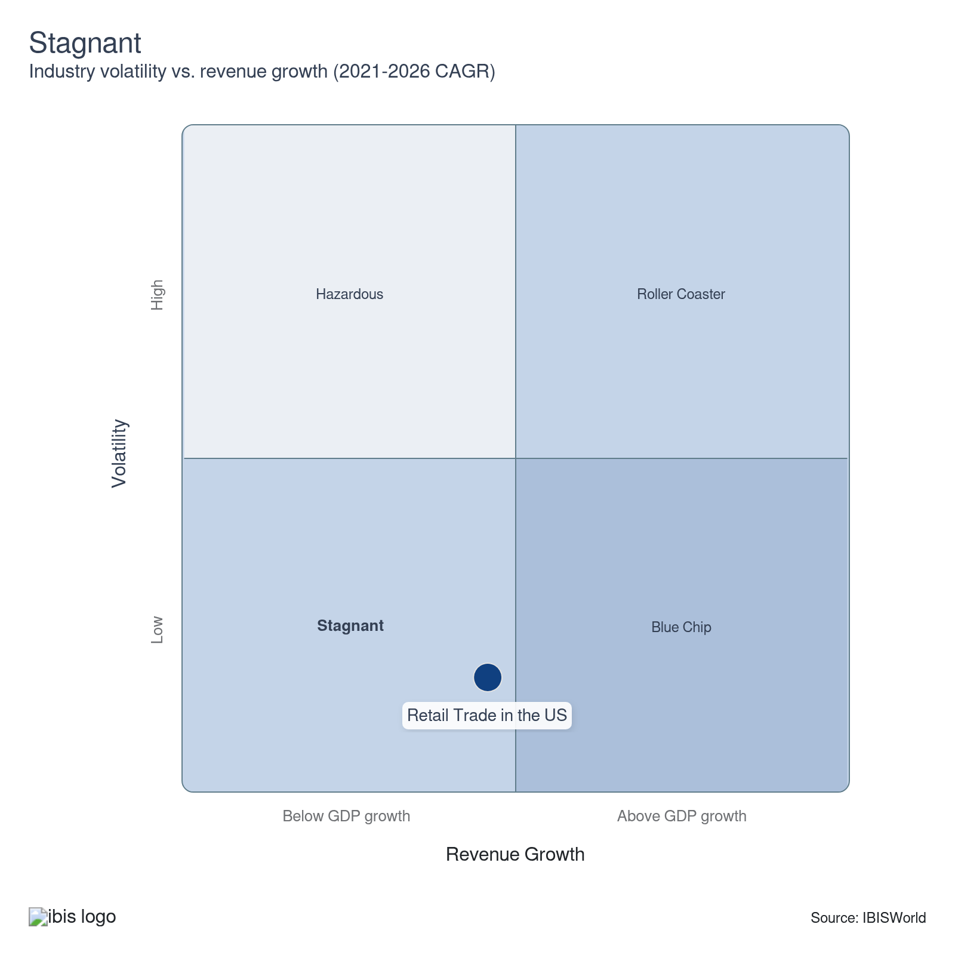

How do successful businesses overcome volatility?
Establish long-term working relationships with raw material suppliers
Securing long-term working relationships with raw material suppliers stabilizes supply chains, ensuring consistent product availability even during market fluctuations. These reliable partnerships allow retailers to manage costs, maintain inventory levels and reduce the impact of market volatility.
Optimize operating capacity
Optimizing operating capacity allows retailers to adjust production and distribution efficiently in response to demand. This flexibility helps manage costs and mitigate risks associated with market volatility, ensuring that resources are effectively utilized and preventing overproduction or stock shortages.
Outlook | ↑ 2026-31 Revenue CAGR +2.1%

What's driving the industry outlook?

Artificial intelligence will enhance all aspects of retail operations
- Artificial intelligence will overhaul the retail sector through smarter forecasting, dynamic pricing and personalized shopping experiences. The push comes from retailers’ need to cut costs, manage supply chains more precisely and keep pace with consumer expectations shaped by digital-first brands. AI models will analyze massive streams of purchasing data, revealing what shoppers want before they do—helping stores fine-tune inventory and reduce waste. Walmart’s seasonal demand predictions show how predictive analytics can align purchases with consumer behavior.
- Delivery logistics will also advance. AI-powered optimization will continuously recalibrate delivery routes, curbing fuel use and delays. Retailers that deploy these systems can expect better profit and happier customers—a dual win that tightens supply chains and bolsters loyalty.
- Competition will intensify as AI enables real-time pricing adjustments based on consumer demand, cost inputs and rivals’ movements. According to Nvidia’s 2024 survey, 69.0% of retailers credit AI with boosting annual revenue, with 15.0% reporting a 15.0% or greater jump.
- Personalization will keep shoppers hooked. Machine learning systems will profile preferences, habits and purchase history to tailor experiences—from curated online recommendations to targeted in-store promotions. Amazon’s product-suggestion algorithms already show how AI can drive conversions, and omnichannel retailers can capture similar gains by merging digital insights with physical-store data.
- AI will also strengthen security. Enhanced facial recognition and predictive surveillance systems can cut theft, which remains one of retail’s biggest cost drains. With theft-related losses topping $110 billion in 2022, major chains like Walmart and Target are turning to AI tools to safeguard stock, protect profit and keep stores open in high-risk areas.

Economic uncertainty will push consumers toward value-driven retailers as spending confidence recovers slowly
- Over the next five years, the retail sector will face a mixed economic climate defined by moderate income growth and uneven consumer confidence. Per capita disposable income will rise at a projected 2.1% CAGR through 2031, yet consumer confidence is estimated to drop by 23.0% over the same years, reflecting worker uncertainty and lingering inflation fears. The result will be a cautious spending environment where shoppers prioritize value over indulgence, even as nominal incomes continue to climb.
- A short-term uptick in unemployment in 2026, combined with higher energy prices, will put pressure on household budgets and retail margins. However, as interest rate cuts take effect from 2025 and potentially from additional cuts in 2026, lower borrowing costs will eventually stimulate labor markets and revive consumer appetite for non-essential goods.
- In the meantime, retailers can expect a “trading-down” effect across the board. Shoppers will stretch their dollars by buying fewer premium goods, favoring value-oriented brands and private labels. This behavior will keep overall spending stable but shift sales volume toward discounters, dollar stores and warehouse clubs that offer perceived affordability.
- Mid-market specialty retailers, especially those without substantial discount or loyalty strategies, may see volatile traffic and shrinking profit. To defend profit and attract value-conscious consumers, retailers will need to lean on technology and data analytics to deliver smarter promotions, personalized discounts and loyalty-driven engagement.
- As confidence gradually rebounds later in the period, retailers that maintain trust through transparent pricing, consistent value and omnichannel convenience will be best positioned for renewed growth. Strategic flexibility—adapting quickly to shifting consumer moods—will determine which brands thrive amid the macroeconomic push-and-pull.

Tariff reversals could ease pressure on retailers, but renewed trade tensions keep costs unpredictable
- The global trade landscape is still weathering a turbulent phase, driven by renewed U.S. tariff measures and political brinkmanship. In 2025, the Trump administration’s policy hiked duties to 35.0% and 25.0% on non-USMCA-qualifying imports from Canada and Mexico, respectively, while Chinese imports faced additional surcharges layered on top of existing Section 301 rates. Though the U.S. Supreme Court struck down these tariffs in early 2026, the administration’s push for alternative mechanisms keeps trade conditions uncertain.
- For the retail sector, this instability translates into sustained cost pressures and planning difficulties. Import-heavy categories—electronics, apparel, furniture and household goods—face higher input prices and reduced profit. Companies must decide whether to absorb these costs or pass them to consumers, either of which erodes competitiveness in a price-sensitive market.
- The consumer impact is already visible. The Tax Foundation and other groups estimated that the average tax burden for US households climbed to between $1,000 and $2,000 in 2025, dampening discretionary spending and retail sales.
- In February 2026, the US Supreme Court struck down the tariffs with a 6-3 decision. The Yale Budget Lab estimates this will halve the average household’s budget burden to between $600 and $800. Renewed policy battles could still reverse this relief, as the Trump administration has remained adamant about its trade policy, keeping sentiment fragile and purchasing behavior cautious.
- Retailers can hedge against tariff shocks by diversifying suppliers beyond China and North America, investing in nearshoring or localized production and using inventory analytics to mitigate disruption. Private-label strategies and loyalty-driven promotions can also offset price sensitivity, helping to retain customers even as costs fluctuate.

Extended reality will engage a new generation of shoppers
- Retailers are betting on extended reality technologies like augmented and virtual reality to attract tech-savvy Generation Z and millennial consumers, who are more receptive to these innovations than older shoppers. These technologies will connect digital and physical retail experiences, enhancing consumer engagement and satisfaction.
- Augmented reality (AR), known for enabling customers to visualize products in their spaces, will transform product discovery and decision-making processes. Furniture companies like IKEA offer AR-powered apps that let customers see how different pieces fit in their homes before purchase, boosting buyer confidence and reducing return rates.
- Virtual reality (VR) will create immersive online shopping experiences, allowing customers to explore stores from home digitally. This implementation could drastically reduce retailers' operational costs by minimizing the need for large storefronts while introducing new revenue streams through VR experiences.
- Companies like Sephora and Warby Parker offer virtual try-ons for makeup and eyewear using extended reality (XR) technologies to personalize the shopping experience. These features use consumers' devices to overlay or simulate digital content, helping them visualize products, explore virtual stores and receive interactive guidance. This tailored shopping can lead to increased sales and profit as customer engagement, satisfaction and brand loyalty rise.
- As younger consumers dominate more of the retail sector’s sales, retail brands looking to stay relevant can innovate using XR. Embracing AR and VR early could position these retailers ahead of the competition and redefine brand experiences, helping sustain growth in a digital marketplace.
- However, despite its promise, integrating XR faces hurdles such as high development costs and technical complexity. Retailers venturing into XR must invest substantially in technology and expertise while ensuring strict compliance with data protection laws and avoiding security risks associated with processing personal data.

Reverse logistics is turning returns into profit and sustainability gains
- The shift toward a circular economy is redefining how retailers handle returned goods. Instead of relying on the traditional linear “make-use-dispose” model, the circular system emphasizes reuse, refurbishment and recycling. Reverse logistics—the process of managing products after sale for returns, repairs, or resale—is at the heart of this change. The push comes from growing consumer demand for sustainable practices, corporate ESG commitments and mounting financial pressure to reduce waste-related costs.
- U.S. retail returns reached an estimated $849.9 billion in 2025, according to NRF. This means consumers returned around 19.3% of online sales, so the stakes are high. Unprocessed returns send an estimated 5.8 billion pounds of waste to landfills annually, underscoring both the environmental and operational burden. Retailers are now turning those challenges into opportunities, using reverse logistics to recapture product value and lower disposal expenses.
- Sustainability-minded consumers are driving the momentum. Nearly half of millennials and Gen Z say they’ll pay more for eco-friendly products, while inflation has boosted interest in refurbished and remanufactured goods. The result is a thriving secondary market where affordability meets environmental responsibility—an opportunity for retailers to connect with younger, values-driven shoppers whose purchasing power continues to rise.
- Retailers embracing the “5 R’s” of reverse logistics—returns, reselling, repairs, repackaging and recycling—are not only cutting costs but also reinforcing brand loyalty. By weaving these strategies into operations, companies can extend product lifecycles, minimize waste and enhance customer trust.
Life Cycle | Mature

Why is the industry mature?

Contribution to GDP
The retail trade sector plays a vital role in the economy and is known for consistently boosting GDP through high consumer spending and robust sales – particularly in the current period. The more than $1.7 trillion contribution expected in 2025 underscores the sector’s mature presence and ongoing importance in the economy, and the degree to which it drives national financial health and supports growth.

Market Saturation
The retail sector’s market saturation varies across its subsectors, but all retailers continually compete fiercely for consumers’ attention and spending. This intense competition is reflective of the sector’s maturity, while pushing companies to stand out through unique offerings and novel customer loyalty programs to navigate and thrive in the crowded marketplace.

Innovation
Innovation remains crucial on multiple fronts in retail, with many retailers focusing on omnichannel marketing strategies and process automation to meet evolving customer demands. In this mature stage, many businesses take a creative approach to be able to integrate online and in-store experiences, aiming to ensure they stay relevant and engaging as technology changes and digital dynamics continue to reshape buyers’ habits.

Consolidation
Consolidation trends vary among retail subsectors, reflecting a mix of decline and growth. While mature industries like Camera Stores (IBISWorld report 44313) consolidate to optimize resources, growing industries like those with burgeoning e-commerce markets are more competitive, which facilitates fragmentation.

Technology & Systems
Technology shapes the retail sector’s operating environment through advancements in processes and systems like contactless payment, inventory management and digital marketing. More prominent, well-established retailers lead in this area due to their ability to invest in new technologies to streamline operations and enhance customer experiences. The widespread adoption of digital tools reflects this mature sector’s ability to adapt and innovate.

4. Products and Markets
https://my.ibisworld.com/us/en/industry/44-45/products-and-markets
Largest Market  $2.4tr  Other retailers | Product Innovation  Moderate

Key Takeaways
- Motor vehicle and parts dealers lead in sales due to their high-ticket nature and adaptability. Auto dealers that offer a mix of new and used vehicles can navigate economic fluctuations with more agility and tap into diverse consumer needs.
- Consumers aged 45 to 64 are retail heavyweights, i.e. they tend to purchase big-ticket luxury items. Yet with their typically sizeable disposable income, they prioritize quality and convenience, giving retailers opportunities to enhance profit through premium offerings.
- Health and personal care stores are thriving, driven by an growing population that is of advanced age and heightened health consciousness across demographics. With a significant sales surge since 2021, these stores are capitalizing on consumers’ rising prioritization of health-related purchases.

Products and Services
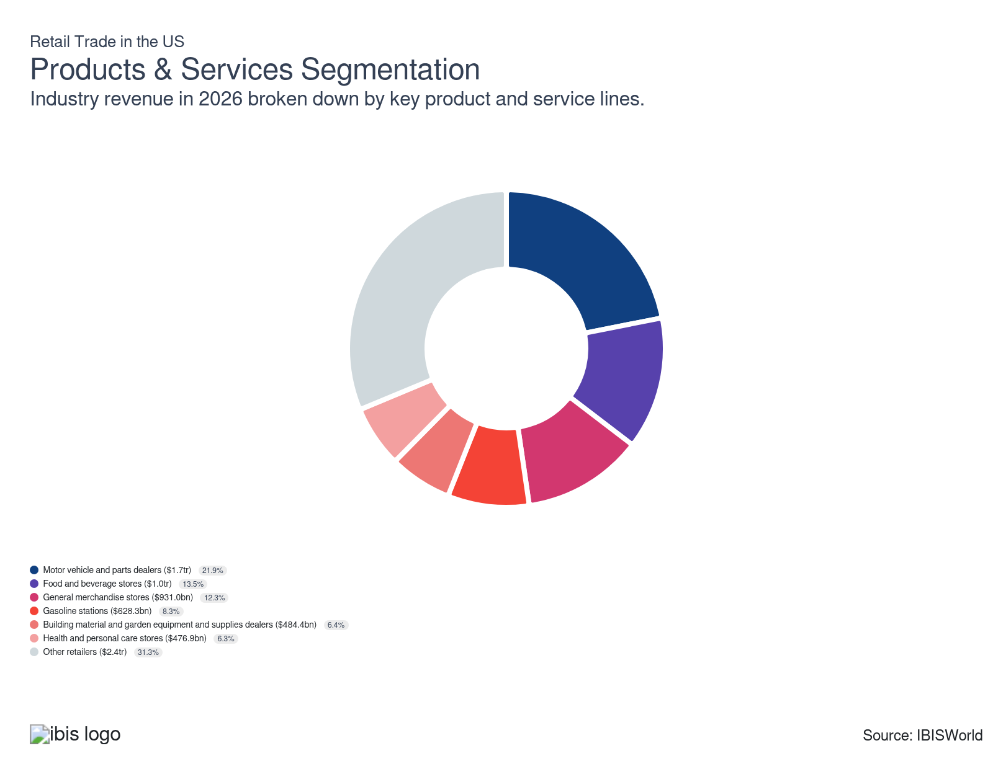

How are the industry’s products and services performing?

Rising incomes and shifting economic cycles balance new and used vehicle and parts sales
- Motor vehicles and auto parts make up the largest share of retail trade revenue because of their high-value transactions and necessity in daily transportation. Their performance anchors the entire retail sector, even as consumer demand shifts with economic cycles.
- New and used vehicle sales offset each other cyclically—rising incomes boost new vehicle purchases, while downturns lift used vehicle and parts sales—creating a natural buffer against volatility in the subsector.
- Inflationary pressures in 2021 and 2022, which drove vehicle prices up nearly 16%, initially slowed sales. However, momentum has returned. In 2025, dealerships reported 5.2% higher new vehicle sales and 6.3% growth in parts and service revenue, according to NADA data.

Cooling food prices and dining-out trends slow grocery store revenue growth.
- Food and beverage stores deliver steady revenue for the retail sector thanks to the non-discretionary nature of their products. Consumers continue to buy staples regardless of economic conditions, stabilizing income even during downturns.
- Significant jumps in the agricultural price index bolstered sales early in the period. Grocers can transfer higher costs to consumers more easily than discretionary retailers, maintaining profit. In tough economic periods, shoppers often increase spending on food and beverage essentials while cutting back on other goods, helping this subsector anchor retail trade performance when consumer budgets tighten.
- Agricultural price drops, dining-out normalization and meal-kit subscription services have pushed food services and drinking places to stronger gains than stores in recent years. A Farm Bureau analysis notes Americans spent 40.0% more on food away from home in 2024 than earlier, pressuring grocery stores and supermarkets to offer quick, convenient options.

General merchandise stores sustain retail strength through low prices and digital expansion
- General merchandise stores—ranging from department stores to warehouse clubs and dollar stores—generate strong revenue by offering extensive product variety that appeals to mass-market consumers. Their breadth enables them to balance demand across product categories and serve as a convenient one-stop shop.
- Traditional department stores face intense pressure from e-commerce rivals. Still, leading chains such as Walmart and Target have reduced this impact by promoting their own digital sales channels and enhancing in-store pickup options.
- Large retailers use economies of scale to sustain low prices and elevated online revenue streams, highlighted by online sales accounting for 18.0% and 19.6% of Walmart's and Target’s 2024 revenues, respectively. These adaptive strategies keep major chains central to retail trade performance despite ongoing digital disruption.

Falling fuel prices and EV adoption push gas stations toward convenience store-driven growth
- Gasoline stations remain crucial for consumers nationwide, though their revenue growth has been moderate amid persistent declines in oil and natural gas prices. Competitive pricing limits profit, and a 17.2% drop in oil prices in 2023, followed by another 15.0% dip in 2025, curbed overall sector revenue. However, lower pump prices encouraged greater fuel consumption, lifting sales volumes and sustaining turnover.
- The rise of hybrid and electric vehicles continues to reduce reliance on traditional gasoline stations, as charging stations can be integrated into homes, store parking lots and other convenient locations, shrinking the segment’s share of retail revenue and forcing businesses to adapt.
- Modern fuel retailers are responding by enhancing convenience store offerings and amenities. Stations with robust food, beverage and retail assortments now account for roughly 80.0% of fuel purchases, according to the National Association of Convenience Stores, underscoring diversification as a key growth strategy.

Expanding home improvement spending bolsters building material, garden equipment and supplies dealers
- Building material, garden equipment and supplies sales fluctuate with the health of the residential market, encompassing home improvement, hardware, outdoor equipment and garden stores. These businesses thrived during the pandemic as consumers invested in home upgrades, but faced slower demand in 2023 amid rising interest rates and materials inflation.
- Since 2024, rebounding home improvement spending has strengthened profitability for hardware and building material retailers, reflecting renewed homeowner confidence and construction activity. The Federal Reserve’s rate cuts are expected to further stimulate both consumer renovation projects and new housing starts, creating opportunities for retailers to boost sales through strategic inventory expansions and targeted promotional campaigns.

An aging population and a strong beauty market support health and personal care stores
- Health and personal care stores have strengthened retail trade revenue with a 26.2% sales increase since January 2021, according to the U.S. Census Bureau. Consumer focus on wellness and preventative care continues to energize this segment.
- An expanding aging population and heightened post-pandemic health awareness sustain long-term demand for pharmaceuticals, supplements and other essentials, helping the subsector maintain solid growth despite its relatively smaller share of total retail sales.
- Inflation briefly cooled discretionary spending on beauty products, but as prices normalize, skin care is set to drive renewed category expansion. McKinsey’s 2025 State of Beauty report highlights this rebound, signaling ongoing strength in accessible, health-oriented retail spending.

Macroeconomic conditions drive demand for the remaining subsectors
- The remainder of the retail trade sector comprises specialized consumer goods industries, such as sporting goods, electronics and furniture stores. These establishments cater to niche markets that attract loyal consumer bases.
- Clothing and accessory stores, the largest of these subsectors, exemplify how targeting specific demographics and offering a variety of products can enhance consumer engagement, driving transactional frequency.
- Macroeconomic trends, such as rising disposable income and falling borrowing costs, empower consumers to spend more liberally on nonessential goods, enabling retailers to introduce premium lines and expand profit through strategic pricing.

What are innovations in industry products and services?

Omnichannel boosts the customer experience and provides valuable insight
- Omnichannel retailing ensures a seamless shopping experience across digital and physical platforms, increasing customer satisfaction and loyalty. By tracking cross-channel activities, retailers gain valuable insights into customer preferences and behaviors, enabling effective marketing strategies and personalized customer engagement.
- Shoppers enjoy the flexibility of ordering online and picking up in-store, providing convenience and immediate product access. According to a Salesforce survey, 74.0% of customers expect to be able to do anything online that they can do in person or by phone. The ability to return online purchases in physical stores makes exchanges and returns straightforward, enhancing overall satisfaction.
- Retailers can monitor customer interactions across various channels, enabling data-driven inventory decisions. This information optimizes stock levels and ensures that popular products are readily available, reducing the likelihood of stockouts or overstock.

Extended reality facilitates experiential shopping
- Extended reality (XR) encompasses augmented, virtual and mixed reality technologies. This technology transforms retail operations, offering benefits like adaptability, personalization and multichannel integration. Customers enjoy innovations like virtual try-on experiences, and businesses benefit from the convenience of bringing the store to the consumer’s home.
- Younger demographics, specifically Gen Z and Gen Alpha, are driving the demand for XR. This shift will create opportunities for brands that are targeting these demographics. Legacy brands use XR to reinvent their image and appeal to younger consumers. This initiative positions them as innovators and encourages engagement with new audiences.
- Future developments in XR may even include adding other sensory experiences, like smell, to provide a more immersive shopping experience – opening new paths for in-store and online retailing.

What products or services do successful businesses offer?
Leverage product design, quality and brand strengths
Leveraging product design, quality and brand strengths fosters customer trust and loyalty. High-quality, well-designed products associated with a strong brand attract repeat customers, positive reviews and word-of-mouth referrals, boosting sales and market positioning over time.
Produce a differentiated product
Offering a differentiated product helps retailers stand out in a competitive landscape. Unique features, quality or design can attract specific customer segments, enhancing brand loyalty and enabling premium pricing. It gives retailers a competitive edge by offering something distinct.

Major Markets
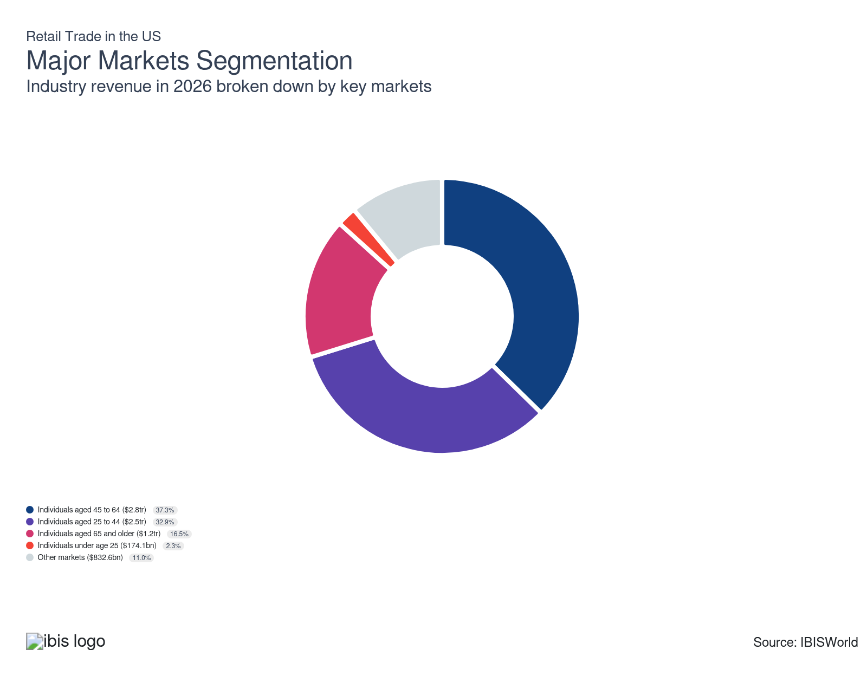

What’s influencing demand from the industry’s markets?

Affluent midlife consumers sustain revenue through premium spending power
- Consumers aged 45 to 64, who are often at the height of their careers and income, generate nearly 40% of total retail trade revenue. Their higher financial security enables frequent purchases of big-ticket items such as vehicles, jewelry and premium home goods, driving profitability across multiple retail categories.
- With fewer dependents and greater control over their finances, this demographic exhibits strong preferences for quality, convenience and brand reliability, helping expand the markets for luxury, specialty and durable goods. Retailers that emphasize premium product assortments, personalized customer engagement and seamless in-store and online experiences stand to capture sustained loyalty and spending from these high-value consumers, reinforcing steady revenue growth in the sector.

Advancing careers for individuals aged 25 to 44 result in heightened spending
- Consumers aged 25 to 44 account for roughly one-third of total retail trade revenue, driven by rising incomes and strong discretionary spending. As this group builds households and families, their purchases increasingly include home furnishings, renovation materials, vehicles and personal wellness products.
- Career advancement and income growth enhance their ability to spend on both essential and aspirational goods, sustaining broad sector demand and profitability.
- Retailers can strengthen engagement by tailoring marketing and products toward this group’s evolving life stages—offering family-oriented merchandise, home improvement solutions and convenient digital shopping experiences that match their dynamic, tech-savvy lifestyles.

Individuals aged 65 and older spend more time at home and less time shopping
- Consumers aged 65 and older primarily contribute to retail revenue through purchases of essential goods and services – such as pharmaceuticals, healthcare products and groceries – because of their typically higher focus on health and wellness compared to younger demographics. Investing in user-friendly online platforms and offering tech support bridges the gap for less tech-savvy seniors and fosters increased e-commerce engagement.
- The limited mobility of many seniors often results in reduced in-person shopping, yet it concurrently boosts demand for services such as home delivery and personalized assistance. This offers retailers an opportunity to boost profit by enhancing customer experience and satisfaction.
- Retirees generally shift their spending away from high-value items and toward modest spending on discretionary items. This segment’s tendencies encourage retailers to focus on affordable, practical products for this demographic, since essential purchases can be a steady source of revenue.

Some retailers sell to other businesses and wholesalers
- The “other” segment, or the remainder of retail sales other than individuals, is largely B2B or “business to business.” Revenue is generated by a wide range of businesses, including professional contractors and building operators, for example, who purchase large quantities of materials and supplies for their projects.
- The B2B focus is especially notable in retail subsectors like building materials and garden equipment, for example, for which nearly half of retailers’ revenue is attributed to professional contractors.
- Wholesalers, distributors and other retailers procuring merchandise from retail outlets for resale are among other small contributors in this segment, particularly in the motor vehicle and parts dealers subsector to the retail sector.
- Offering bulk-purchase options, establishing strong business-to-business relationships and ensuring competitive pricing for quality goods will incentivize sales to other businesses.

Individuals under age 25 are limited by income
- Consumers under 25, a segment characterized by limited spending power, contribute minimally to direct retail revenue. They purchase less-expensive products, or their sales are statistically realized in older age cohorts – i.e., purchased by parents.
- Despite their limited direct contribution, the youngest consumer segment’s openness to innovative retail services offers retailers an opportunity. Engaging them through virtual try-ons and omnichannel experiences can lay the foundation for future growth and brand loyalty, which will solidify as these consumers earn more each year.
- This demographic’s aptitude for digital environments makes them more likely to use technology to easily compare prices and offerings, which pushes retailers to optimize their online platforms for mobile users and to reduce costs associated with traditional advertising that may not reach these audiences.
- Younger consumers prioritize brands that share their values. Retailers that align their offerings and messaging with the values of younger consumers can nurture these relationships and therefore maximize potential revenue from this segment over time.

International Trade

Some industries don't directly import or export goods. See reports at the manufacturing level for international trade data on relevant products.

5. Geographic Breakdown
https://my.ibisworld.com/us/en/industry/44-45/geographic-breakdown

Key Takeaways
- Retailers locate in highly populated areas to expand their potential customer base. Because of its status as the most populated region, the Southeast holds the highest share of retailers.
- The concentration of popular locations varies between subsectors and industries, and depends on the target customer for an industry. For example, online-only retailers may opt for locations with well-developed transportation infrastructure to help facilitate shipping.

Business Locations
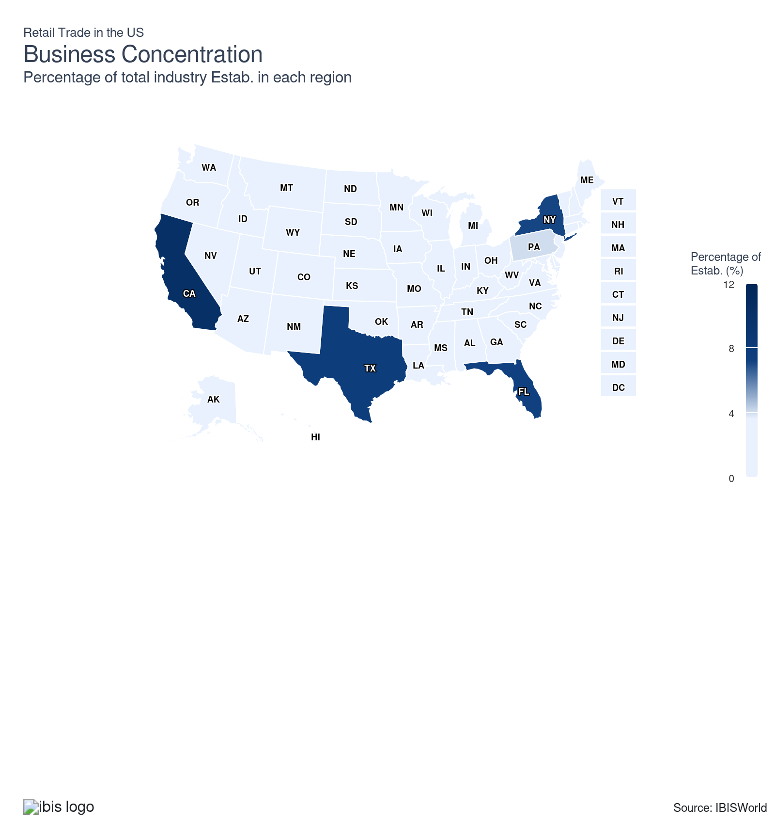
State | Estab.  Units | Estab.  % | Population  %
California | 105548 | 3.2 | 11.5
Texas | 80932 | 2.5 | 9.4
Florida | 74226 | 2.3 | 7.0
New York | 73794 | 2.2 | 5.8
Pennsylvania | 41045 | 1.2 | 3.8
Illinois | 36418 | 1.1 | 3.7
Georgia | 34637 | 1.1 | 3.3
North Carolina | 34506 | 1.0 | 3.3
Ohio | 34372 | 1.0 | 3.5
Michigan | 33088 | 1.0 | 3.0
New Jersey | 30165 | 0.9 | 2.8
Virginia | 26064 | 0.8 | 2.6
Massachusetts | 22773 | 0.7 | 2.1
Tennessee | 22650 | 0.7 | 2.1
Alabama | 17565 | 0.5 | 1.5
Indiana | 20784 | 0.6 | 2.0
Washington | 20897 | 0.6 | 2.3
Missouri | 19926 | 0.6 | 1.8
Colorado | 18462 | 0.6 | 1.8
Arizona | 17602 | 0.5 | 2.2
Minnesota | 17921 | 0.5 | 1.7
South Carolina | 17673 | 0.5 | 1.6
Wisconsin | 18064 | 0.5 | 1.7
Maryland | 17082 | 0.5 | 1.8
Louisiana | 15995 | 0.5 | 1.3
Kentucky | 14817 | 0.5 | 1.3
Oklahoma | 13055 | 0.4 | 1.2
Oregon | 13965 | 0.4 | 1.2
Connecticut | 11737 | 0.4 | 1.1
Iowa | 11147 | 0.3 | 0.9
Mississippi | 11290 | 0.3 | 0.9
Arkansas | 10606 | 0.3 | 0.9
Utah | 10392 | 0.3 | 1.0
Kansas | 9591 | 0.3 | 0.9
Nevada | 8660 | 0.3 | 1.0
Nebraska | 6919 | 0.2 | 0.6
Idaho | 6185 | 0.2 | 0.6
Maine | 5983 | 0.2 | 0.4
New Hampshire | 5739 | 0.2 | 0.4
New Mexico | 6021 | 0.2 | 0.6
West Virginia | 5658 | 0.2 | 0.5
Delaware | 3674 | 0.1 | 0.3
Hawaii | 4486 | 0.1 | 0.4
Montana | 4602 | 0.1 | 0.3
South Dakota | 3725 | 0.1 | 0.3
North Dakota | 3138 | 0.1 | 0.2
Rhode Island | 3620 | 0.1 | 0.3
Vermont | 3033 | 0.1 | 0.2
Alaska | 2369 | 0.1 | 0.2
District of Columbia | 1670 | 0.1 | 0.2
Wyoming | 2550 | 0.1 | 0.2

Where are industry businesses located?

Population growth in the Southeast attracts retailers
- The Southeast region’s population has grown substantially in recent years, directly impacting demand for goods and services and promoting retail expansion. This region’s population is also becoming more diverse, presenting a wide range of consumer preferences for retailers to address. Such demographic dynamics create a thriving market that attracts local and national retail entities to establish more outlets to meet consumer needs.
- Several states in the Southeast, such as Florida, are characterized by a business-friendly climate with favorable tax policies and relatively fewer regulatory barriers. The resulting lower cost of operations makes it economically viable for businesses to expand and open new locations in these states, attracting new businesses and large retail chains, as acquiring land or leases is easier.
- The Southeast US is also a prominent tourist destination, drawing millions of visitors annually with its beaches, historical landmarks, theme parks and favorable climate. Florida, in particular, is a significant attraction for domestic and international tourists. The continuous influx of tourists contributes substantially to retail sales, necessitating a strong retail infrastructure to serve the needs of residents and visitors. The tourism sector’s heightened foot traffic and consumer spending bolster retailers’ growth and sustainability.

Demand from the Mid-Atlantic is spurred by urban hubs
- The Mid-Atlantic region is a hub of commerce and transportation with well-established infrastructure. With robust transportation networks – including highways, railways and ports – retailers can efficiently distribute their products locally and to other regions. For example, the position of the Northeast Corridor railroad line through this region provides easy access to major urban centers and large consumer markets. This connectivity makes the Mid-Atlantic a prime location for warehousing, distribution and retail.
- New York and Pennsylvania, as part of the Mid-Atlantic region, are home to some of the largest and most influential cultural and economic centers in the US. The Mid-Atlantic hosts a dense, diverse and affluent population that boasts pronounced purchasing power. Major cities like New York and Philadelphia offer a mix of consumer demographics, from young professionals to established families. This diversity allows retailers to cater to various tastes and preferences, providing ample opportunities for niche and specialty stores alongside major retail chains.
- New York City is a global fashion and business hub, motivating retailers to establish themselves where they can be at the forefront of emerging retail trends. Iconic retail districts such as Manhattan’s Fifth Avenue and regional shopping centers throughout the Mid-Atlantic contribute to the region’s retail density, making it a desirable location for businesses looking to enhance their brand visibility and prestige.

California leads demand from the West
- The West, particularly California, boasts a large and diverse population. California is the most populous state in the US, with more than 39 million residents and higher-than-average household income – making the Golden State home to a substantial amount of customers who are willing to pay for higher-margin products.
- The broader region’s demographic mix provides a vast customer base from the upper Pacific Northwest to Hawaii, allowing retailers to cater to varied tastes, preferences and cultural backgrounds. Retailers locate where the potential for sales is highest, and a large, multicultural population in the West means more potential customers.
- This region is a major tourist destination, drawing millions of visitors each year. California hosts Disneyland and other large amusement parks, in addition to landmark national parks and beaches. The influx of tourists to the iconic, vast landscapes and cultural attractions throughout the Western states creates a dynamic regional retail market, as travelers are eager to shop for souvenirs and local products, driving sales for the sector.
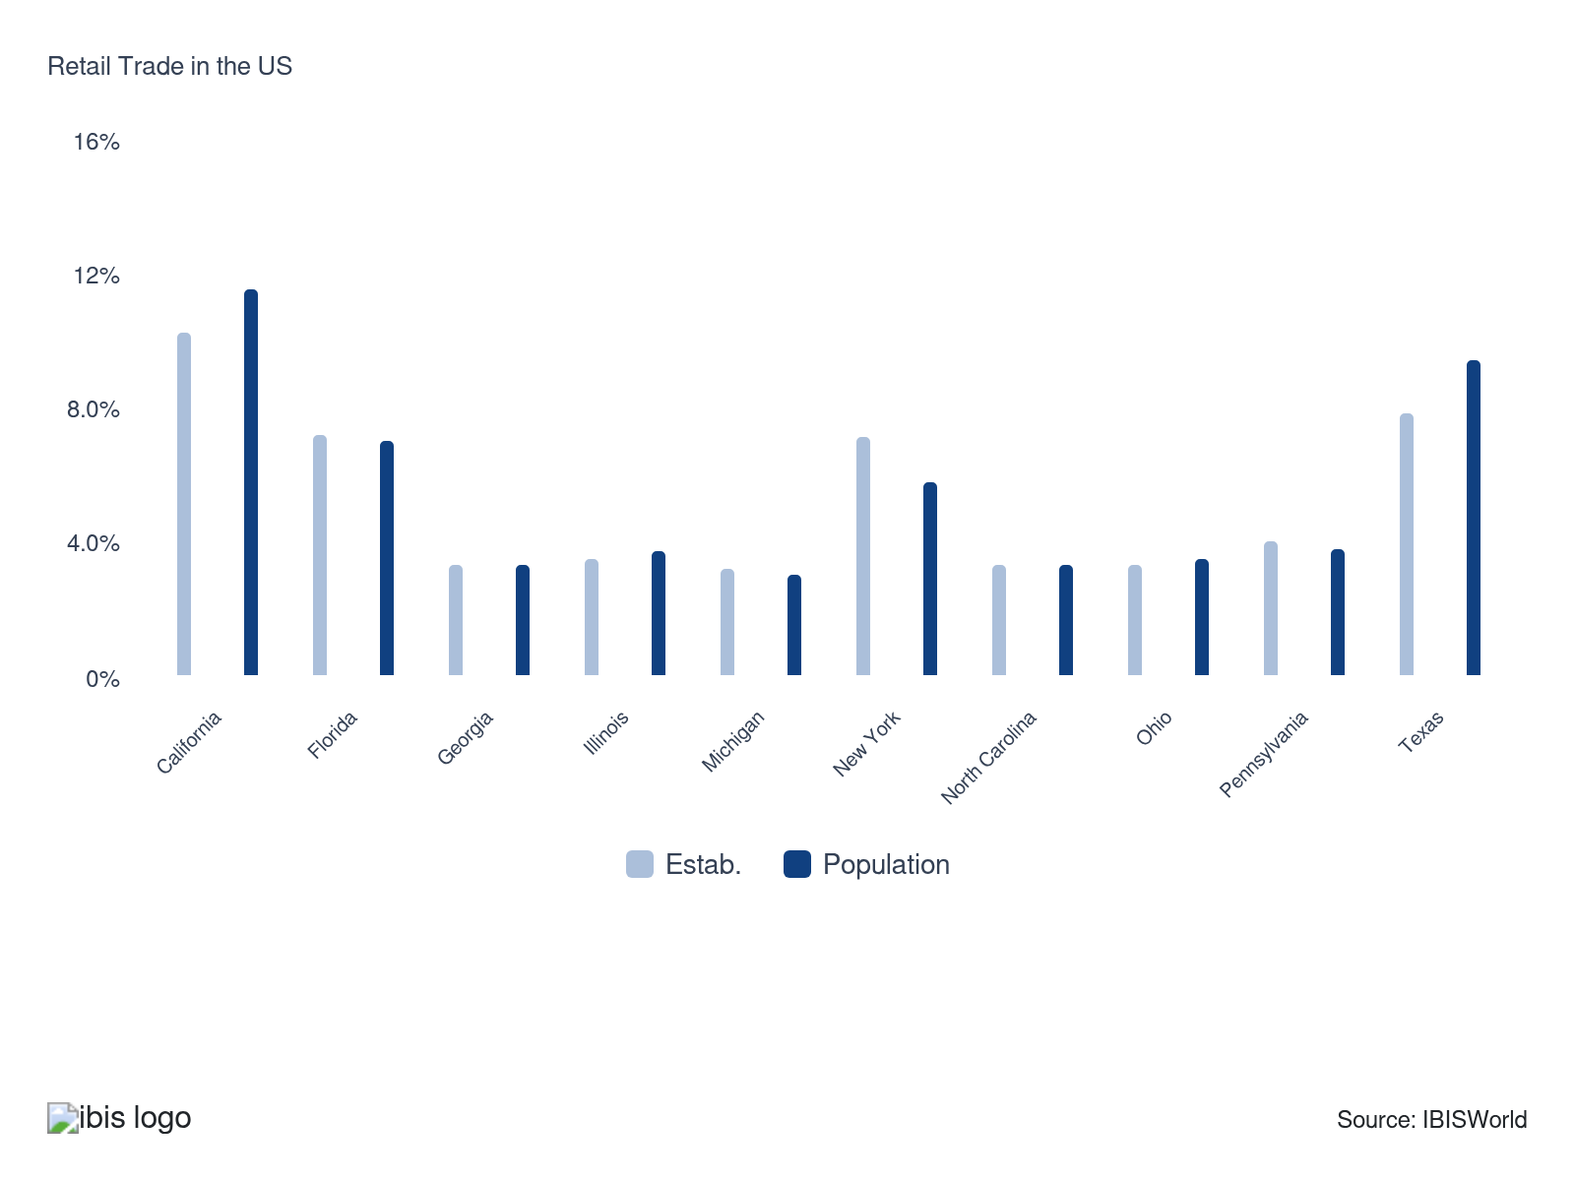

How do businesses use location to their advantage?
Operate in a location that is close to transport
Online-only retailers, for example – or those heavily relying on e-commerce sales – benefit from locating near well-developed transportation infrastructure. Access to major highways or ports helps reduce transportation costs across the supply chain.
Operate in a highly visible location
Operating in a highly visible location is crucial for retail success as it maximizes foot traffic and brand exposure. A prominent location attracts more potential customers, increases impulse buys and improves overall sales performance, driving business growth.

6. Competitive Forces
https://my.ibisworld.com/us/en/industry/44-45/competitive-forces

Key Takeaways
- Internal competition is more prevalent than external competition. Because many retailers sell similar goods, like food or clothing, competition among retailers within the same industry is high in this sector.
- Consumers wield growing power in retail. With easy access to e-commerce and price-comparison tools, they’re in the driver’s seat, pushing retailers to keep prices competitive and customer satisfaction high.
- Substitutes are shaking up the retail game. Consumers direct purchasing from wholesalers and manufacturers is gaining traction, compelling retailers to develop loyal customer bases and offer competitively priced products to stay relevant.

Concentration
Low
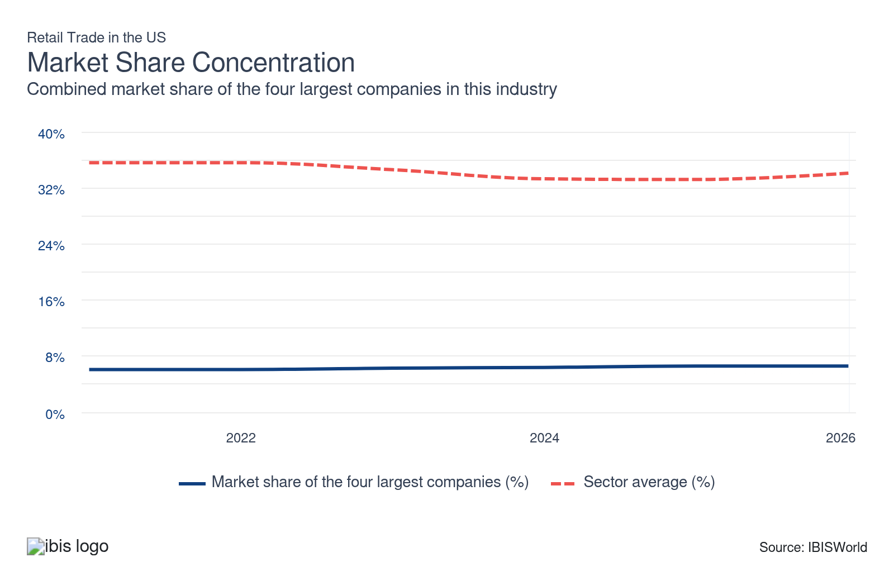

What impacts the industry’s market share concentration?

Consumers’ diverse preferences keep retail fragmented
- Retail remains fragmented because consumers demand a wide range of products, services and shopping experiences. Large retailers like Walmart and Amazon attract customers with variety and convenience. However, many shoppers still prefer specialty stores, local shops or niche retailers that offer unique products and personalized service. This fragmentation spreads revenue across the sector’s many competitors, limiting the dominance of a few big names.
- Cultural tastes, regional lifestyles and shifting fashion and food trends intensify fragmentation. Retailers catering to local or unique preferences may dominate smaller markets, but they struggle to outcompete massive chains on price or variety, preventing concentration from consolidating at the sector-wide level.

Industry scale variation shapes market structure
- Market concentration depends heavily on the sub-industry, with some areas dominated by a few leaders while others are highly fragmented. For example, Walmart and Costco largely control the Warehouse Clubs and Supercenters industry (IBISWorld report 45291), but other segments like Meat Markets (IBISWorld report 44521) or Shoe Stores (IBISWorld report 44821) remain scattered across many small competitors. This structural diversity reduces consolidation within the broader sector.
- Because large-scale companies and local stores coexist, no single model overtakes the sector as a whole. The balance between dominant retail giants and regionally focused businesses maintains low concentration, creating a competitive environment where innovation and diversity of offerings constantly reshape the market.

E-commerce’s recent proliferation reshapes competition
- The recent boom in e-commerce has reshaped the competitive landscape of retail by creating opportunities for small entrepreneurs and established brands to build direct-to-consumer channels. Online platforms like Shopify, Etsy and Amazon Marketplace have reduced the traditional entry costs, enabling countless niche retailers to reach audiences nationally and globally without heavy infrastructure investments. This democratization of market access spreads revenue across thousands of smaller stores and prevents a handful of traditional giants from locking in dominance.
- Even though Amazon is the most powerful force in online retail, the long-tail effect of e-commerce ensures that niche brands can thrive by serving specialized consumer interests. From sustainable fashion to health-focused snacks, these targeted offerings win loyalty among buyers who value unique experiences.

How do successful businesses handle concentration?
Leverage product design, quality and brand strengths
Well-designed, high-quality products and a reputable brand can attract loyal customers, enabling a retailer to stand out and command premium pricing.
Generate repeat customers
Given the sheer size of the retail trade sector in the US, competition is fierce. Retailers can focus on customer satisfaction and loyalty programs to keep customers coming back, which will increase customer lifetime value and provide the steady revenue stream essential for long-term success.

Barriers to Entry
Low | Steady

What challenges do potential industry entrants face?

Legal
- Operating within the retail trade sector requires compliance with extensive regulations, including zoning laws, workplace health and safety standards and business licensing requirements. These legal hurdles can be time-consuming, posing a significant barrier to newcomers who must ensure their establishments meet all necessary legal criteria to operate lawfully and avoid penalties.

Start-Up Costs
- Entering the retail trade sector involves substantial start-up costs, including expenses for leasing retail space, purchasing inventory and investing in technological infrastructure. These financial demands can be prohibitive for entrants who lack significant capital or access to funding, which impedes their ability to compete effectively.

Differentiation
- Establishing a unique brand identity in the retail sector is challenging because of intense competition among well-established brands. Newcomers must differentiate themselves through distinctive product offerings or customer experiences – or a combination of both – which requires strategic planning and marketing expertise.

Labor Expenses
- Retail is labor-intensive, as stores need workers to manage inventory, serve customers, prevent losses and coordinate logistics, among other tasks. In addition to the cost of wages, businesses must hire, train and schedule employees, which demands time and expertise. A solo worker can start lean, but limited coverage caps sales and resilience. Growth can quickly introduce payroll burdens.

How can potential entrants overcome barriers to entry?
Ensure ready access to investment funding
New entrants inherently need seed funding to cover initial costs like inventory procurement, store setup, branding and marketing. With sufficient capital, retailers can establish their presence properly and scale operations as needed.
Ensure proper licensing
Various local, state and federal licenses are required to operate legally and avoid costly penalties or shutdowns, which would not only adversely affect the ability to generate revenue but could potentially impact reputation as well.

Substitutes
Low | Increasing

What are substitutes for industry services?

Wholesalers and manufacturers
- The rise of e-commerce and mobile shopping has enabled wholesalers and manufacturers to connect directly with consumers and businesses, bypassing traditional retail channels. This shift offers price-conscious buyers access to lower-cost goods without retailer markups, making direct purchasing more appealing.
- Many producers now operate online storefronts or use major digital marketplaces to showcase and distribute their products, offering convenience once limited to retail. These direct-to-consumer (DTC) models also let brands control customer data, pricing and loyalty initiatives.
- As consumers embrace buying straight from the source, wholesalers and manufacturers intensify price competition, eroding the retail sector’s profit. Stores must sustain their market relevance through better customer experiences, exclusive product offerings and value-added services.

How do successful businesses compete with substitutes?
Develop a loyal customer base
Developing a loyal customer base is critical for combating substitute competition. By focusing on customer service, personalized experiences and loyalty programs, retailers can foster strong connections with customers. Loyal customers are less likely to switch to substitutes.
Offer a competitively priced product
Offering a competitively priced product is essential to stay attractive in the face of substitute competition. Strategic pricing can deter customers from considering alternative products, helping to maintain market share and drive sales by appealing to price-sensitive consumers.

Buyer & Supplier Power
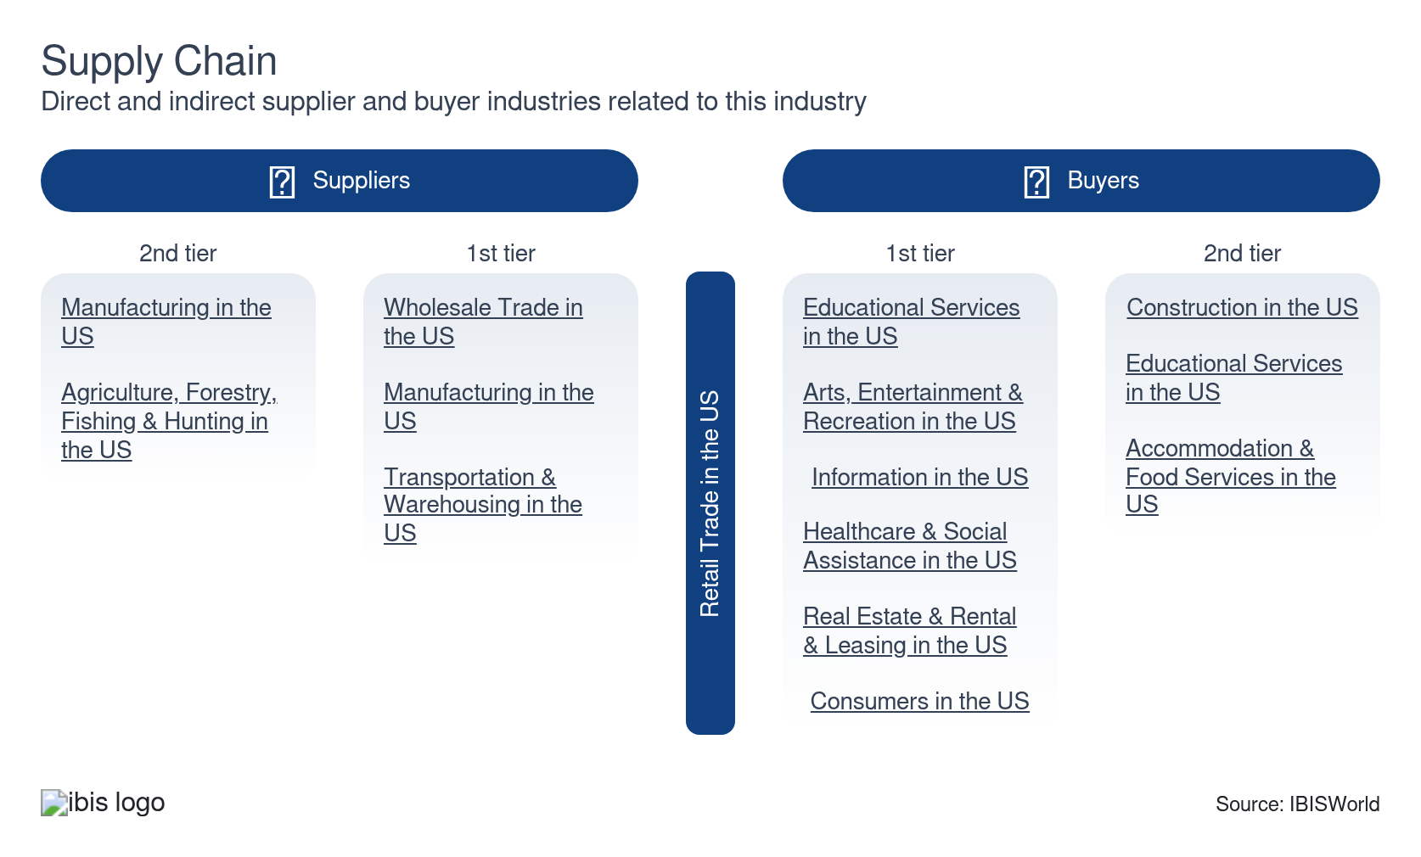

What power do buyers and suppliers have over the industry?

Buyers: E-commerce increases consumers' power
Moderate | Increasing
- Modern consumers have easy access to comprehensive product information and reviews online, enabling them to make well-informed purchasing decisions – reducing reliance on and interaction with customer service. This information also facilitates product comparison and enables buyers to seamlessly switch brands or retailers.
- With continuous availability of promotional offers and price comparison tools, shoppers can easily find the best deals – putting pressure on retailers to maintain competitive pricing.
- Buyer power within the retail sector depends on the industry and a given product’s level of demand. For example, consumers’ willingness to pay increases alongside their demand for a product, limiting buyer power for those seeking high-demand goods like consumer electronics and jewelry.

Suppliers: Economies of scale and brand names fortify suppliers’ position
Moderate | Steady
- Large-scale manufacturers can produce goods at a lower cost per unit, enabling them to offer competitive wholesale pricing that smaller suppliers can’t match and giving them more control over market conditions. As a result, these goods tend to be well-established brands.
- Retailers need these popular products on shelves to attract consumers, which grants their manufacturers significant leverage over retail businesses. In addition, suppliers that offer exclusive or highly differentiated products wield more power since there are inherently fewer alternatives for those products, making retailers more reliant on their suppliers.

How do successful businesses manage buyer & supplier power?
Develop links with suppliers
Long-term working relationships with suppliers help secure a reliable supply chain and enable retailers to negotiate favorable terms. Consistent supply at stable prices mitigates risks of market fluctuations and supply disruptions, empowering retailers to maintain steady inventory levels.
Secure economies of scale
Securing economies of scale helps retailers reduce per-unit costs through large volume purchases and efficient operations. Lower costs improve the retailer’s competitive pricing capability, which can attract more customers and increase market share, and can potentially lead to higher profit.

7. Companies
https://my.ibisworld.com/us/en/industry/44-45/companies

Key Takeaways
- Walmart has captured a significant market share by offering an extensive product selection and maintaining competitive pricing. The company’s dominant position in grocery and its online presence have also helped maintain its position in the sector.
- Amazon has become a major player in the Retail sector by capitalizing on e-commerce growth. Its success is attributed to offering a large product selection, reliability of shipping and unique member benefits.

Market Share
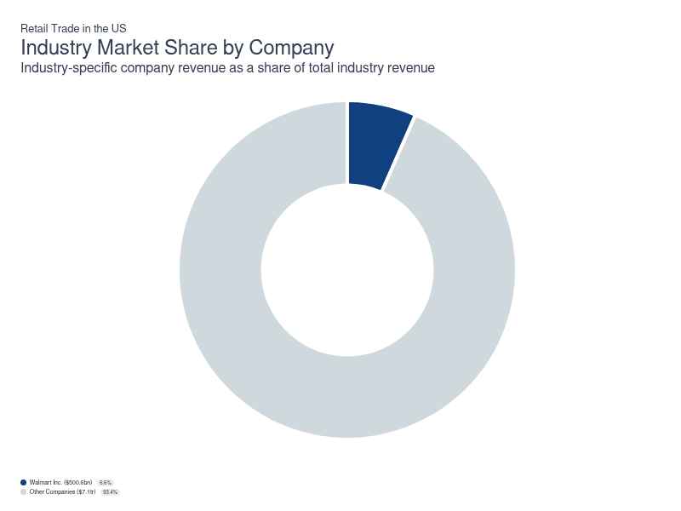
Chart displays current year only in the PDF version of this report. You can view and download chart for all other years associated with this industry on my.ibisworld.com.

Companies
Company | Market Share (%)  2026 | Revenue ($m)  2026 | Profit ($m)  2026 | Profit Margin (%)  2026
Walmart Inc. | 6.6 | 500,553.5 | 20,553.3 | 4.1

Walmart Inc.
Walmart Inc.
Company Details
Company Details
Industry Specific Revenue (2026) | $500.6bn
Industry Profit (2026) | $20.6bn
Company Employees (2026) | 2,100,000
Market Share (2026) | 6.6%

Description
Description
Walmart is a public company headquartered in Arkansas with an estimated 2,100,000 employees. In the US, the company has a notable market share in at least eight industries: Retail Trade, Pharmacies & Drug Stores, Warehouse Clubs & Supercenters, Discount Department Stores, Online Home Furnishings Sales, Online Grocery Sales, Online Children's Toy Sales, Online Office & School Supply Sales and Online Home Furnishings Sales. Their largest market share is in the Warehouse Clubs & Supercenters industry, where they account for an estimated 64.7% of total industry revenue and are considered an All Star because they display stronger market share, profit and revenue growth compared to their peers.

Brands and Trading Names
Brands and Trading Names
- Alert Innovation
- Ans Commerce
- ASDA
- Bonobos
- Botmock
- Carezone
- Cleartrip
- EloquII
- Flipkart.com
- Jet.com
- Joyrun
- Liv.AI
- Phonepe
- Sam's Club
- Walmart Supercenters

Other Industries
Other Industries
- Discount Department Stores in the US
- Online Children's Toy Sales in the US
- Online Grocery Sales in the US
- Online Home Furnishings Sales in the US
- Online Office & School Supply Sales in the US
- Pharmacies & Drug Stores in the US
- Warehouse Clubs & Supercenters in the US

Company’s Industry Revenue, Market Share, and Profit Margin Over Time
Company’s Industry Revenue, Market Share, and Profit Margin Over Time
Year | Industry Revenue ($ million) | Market Share (%) | Profit Margin (%)
2021 | 393247 | 6.1 | 5.5
2022 | 420553 | 6.1 | 4.9
2023 | 441817 | 6.3 | 5.0
2024 | 462415 | 6.4 | 5.2
2025 | 482975 | 6.6 | 5.2
2026 | 500553 | 6.6 | 4.1

What's impacting Walmart Inc.'s performance?

Walmart's omnichannel infrastructure and store density create unmatched competitive advantages
- Walmart's strategic strength lies in leveraging its thousands of physical supercenters as micro-fulfillment nodes that enable same-day delivery covering nearly all US households while avoiding the high fixed costs of dedicated dark stores. The retailer's dense store network maximizes order density per delivery route and dramatically reduces last-mile costs that plague competitors. Walmart's buy-online-pickup-in-store capabilities attract new customers while converting them into higher-value omnichannel shoppers. The company's recent AI and robotics investments, including generative AI shopping assistants, machine learning for route optimization and automated supply chain systems, position it to widen its lead over traditional grocers lacking comparable technology budgets.

Walmart continues to expand drone delivery
- Walmart announced in January 2023 that it had expanded its drone operations across several US states. Since the service was launched in 2021, Walmart now plans to offer drone deliveries from about 150 stores in 2026, with coverage expected to grow to more than 270 Walmart locations by 2027, extending drone delivery access to roughly 10.0% of the US population.

The company highly values diversity in the workplace
- Walmart is a company focused on the inclusion and empowerment of its workforce. In that regard, the company’s employees continue to become more diverse, including more people of color, in addition to more Latinx and Asian individuals. Additionally, the company launched its Accessibility Center of Excellence in May 2021 to help advance inclusion and equity for people with disabilities. In fact, the company scored 100% on the Disability Equality Index (DEI) in 2021, for the sixth year in a row. Moreover, the company donated an estimated $20 million toward furthering equity for Black and Indigenous Canadians.

Walmart Inc. is committed to protecting the environment
- Walmart has implemented numerous sustainable practices and goals related to governance, the environment and society. An example of the company’s efforts to protect the environment is its objective to restore, renew and replenish the environment. In that regard, the company expects that, by 2025, it will be able to sustainably source at least twenty more of its commodities. Through Project Gigaton, the company expects that, by 2030, it will be able to reduce its greenhouse gas emissions by an estimated 1.0 gigaton in its global value chain. Also, the company anticipates that it will help restore and better manage 1.0 million square miles of ocean and 50.0 million acres of land through its Walmart Foundation. Another goal of the company is to reach zero emissions in its global operations by 2040.

Affluent shoppers drive Walmart’s e-grocery growth
- Walmart's e-grocery platform has seen a surge in activity from affluent households, adding to its traditionally strong base of lower-income shoppers. According to Brick Meets Click and Mercatus, high-income households are spending more and ordering more often from Walmart, leading to record e-commerce grocery sales gains. This affluent segment, earning over $200,000 annually, now constitutes about 8.0% of Walmart’s active users, as of 2024, rapidly expanding compared to lower-income shoppers. While supermarkets and Target have experienced weaker online growth among higher-income households, Walmart is capturing a larger share of affluent online grocery spending.

Online opportunities propel growth
- Sam's Club has shifted towards e-commerce and digital innovations. This membership-only retail warehouse club has leveraged data analytics to optimize inventory and personalize the shopping experience. Enhanced digital tools, such as Scan & Go and curbside pickup, resonate with consumers' preference for convenience. An increased emphasis on sustainability has led Sam’s Club to introduce more sustainable Member's Mark product formulations and packaging, including efforts to reduce virgin plastic use and improve recyclability. This blend of technology and eco-conscious initiatives positions Sam's Club competitively in the evolving retail landscape.

Walmart significantly expands e-commerce penetration post-pandemic
- Prior to the COVID-19 pandemic, e-commerce represented less than 5.0% of Walmart's overall sales, highlighting a substantial opportunity for growth. In the years following, Walmart strategically invested in digital infrastructure and online offerings, resulting in e-commerce accounting for more than 11.0% of total revenue. This growth underscores Walmart’s ability to adapt to shifting consumer preferences toward online shopping and its commitment to providing a seamless omnichannel experience.

Walmart unveils AI and in-store experience enhancements
- Walmart has announced new tech initiatives focused on AI enhancements and drone delivery, though they are currently limited to select markets. The company is integrating AI into its supply chain, apps and in-home services, as well as has begun deploying generative AI-powered tools to improve both employee productivity and customer shopping experiences. Meanwhile, Walmart is also focusing on transforming its in-store experience by piloting sensory-friendly hours and adjusting lighting and audio in all stores to better support neurodiverse and sensory-sensitive customers, building goodwill and potentially increasing shopper retention. This strategy aims to accommodate diverse needs and enhance customer satisfaction amid competitive retail environments.

The company has partnered with BEAUTYSPACE NK to launch a new collection of beauty products
- On March 7, 2022, Walmart announced its collaboration with Britain-based retailer Space NK to offer exclusive, high-quality beauty products on its website and in more than 200 of its physical stores. The products launched in March 2022 on Walmart's website and during the summer within its stores. In 2024, Space NK transferred its US wholesale and shop-in-shop operations, including the BEAUTYSPACE NK presence in Walmart, to beauty distributor PCA Companies. Since then, the BEAUTYSPACE NK assortment has continued at Walmart under this new setup, with Walmart posting this collaboration as part of its strategy to make prestige and specialty beauty brands more accessible. This collaboration also makes it even more convenient for shoppers to purchase specialty beauty items, in addition to staple beauty products, in a single trip to Walmart.

You can view and download company details on my.ibisworld.com.

8. External Environment
https://my.ibisworld.com/us/en/industry/44-45/external-environment

Key Takeaways
- Regulations ensure fairness and safety in retail. From fair labor standards to consumer protection laws, retailers must adhere to a myriad of rules. These regulations protect employees and consumers, and help retailers build trust and avoid legal troubles.
- E-commerce is reshaping the retail operating environment. Online shopping’s boom during the pandemic motivates traditional retailers to continue to innovate and embrace digital strategies. This dynamic supports revenue generation and challenges physical store operations to adapt or lose relevance.
- Industry associations are the main form of assistance across the Retail Trade sector. Major associations include the National Retail Federation and the Retail Industry Leaders Association.

External Drivers

What demographic and macroeconomic factors impact the industry?
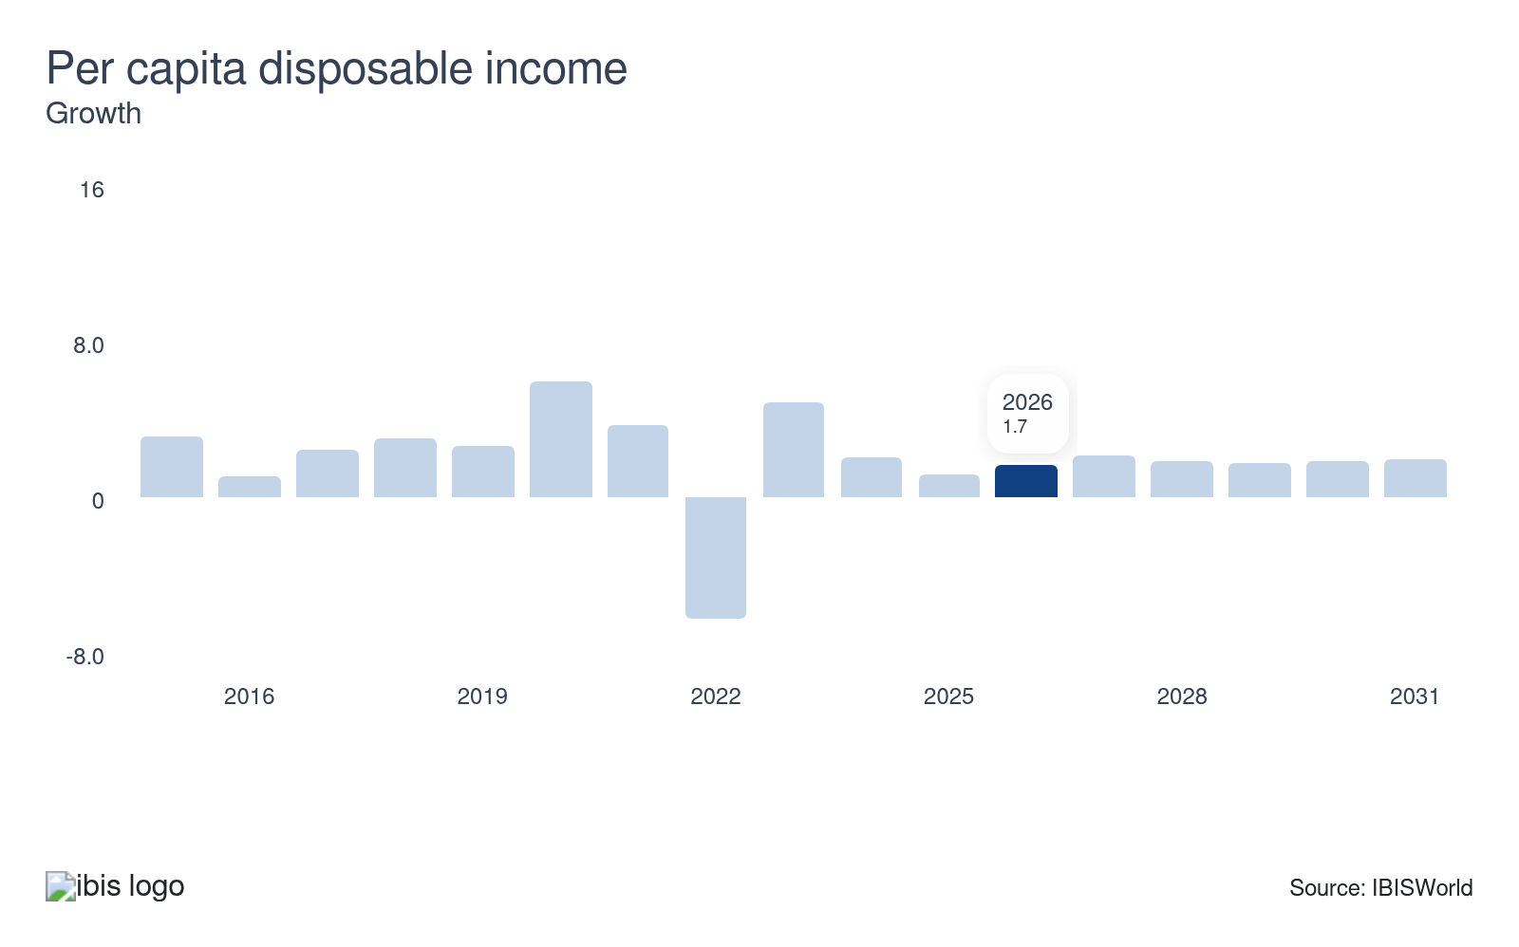
Per capita disposable income is a measure of the average individual’s after-tax income in the US, which indicates that individual’s ability to purchase discretionary goods and services. Consumers tend to limit purchases to essential items and prioritize more affordable brands when per capita disposable income dips, curbing demand for higher-end retail products. Consumers can more easily afford nonessential products when per capita disposable income grows, enabling them to invest in higher-quality items.
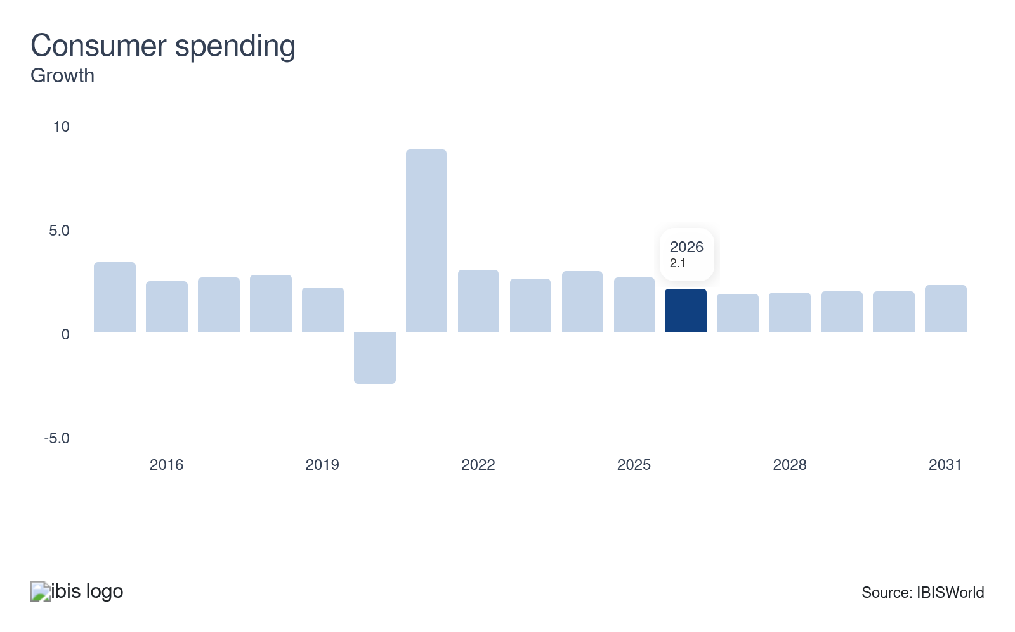
Consumer spending measures the total amount spent on goods and services by US consumers; also known as personal consumption expenditures. When buyers are more confident and have greater purchasing power, consumer spending surges, leading retailers to enjoy increased sales and profit. Conversely, when spending declines, retailers struggle to attract customers since most retail purchases are made by individuals. Lower consumer spending poses a potential threat to the retail trade sector.
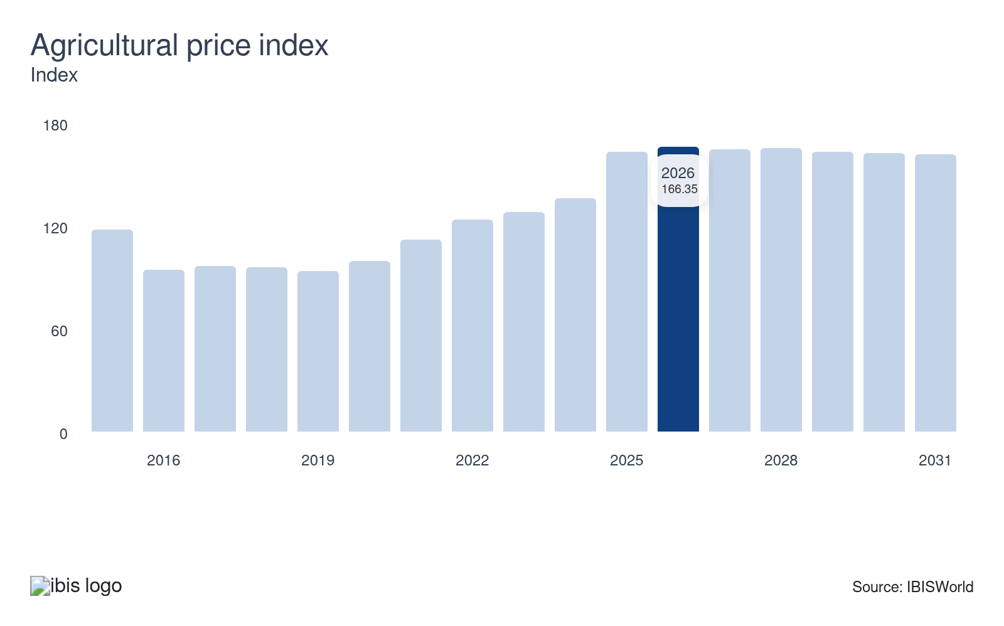
A rising agricultural price index affects retail via escalating grocery costs. When producer prices climb, retailers face higher costs. Since groceries are nondiscretionary, stores are easily able to raise prices. Elevated grocery costs for consumers may hinder their ability to spend on other subsectors, complicating the prices’ effect on overall revenue.

Rising electricity prices directly impact retailers by squeezing operational budgets and consumer spending power. When energy bills climb, retailers and manufacturers face higher costs, which often leads them to raise product prices. Consumers with reduced disposable income tighten their spending in times of higher energy costs, leading to decreased retail sales. This dual pressure creates a challenging environment for both sellers and buyers.
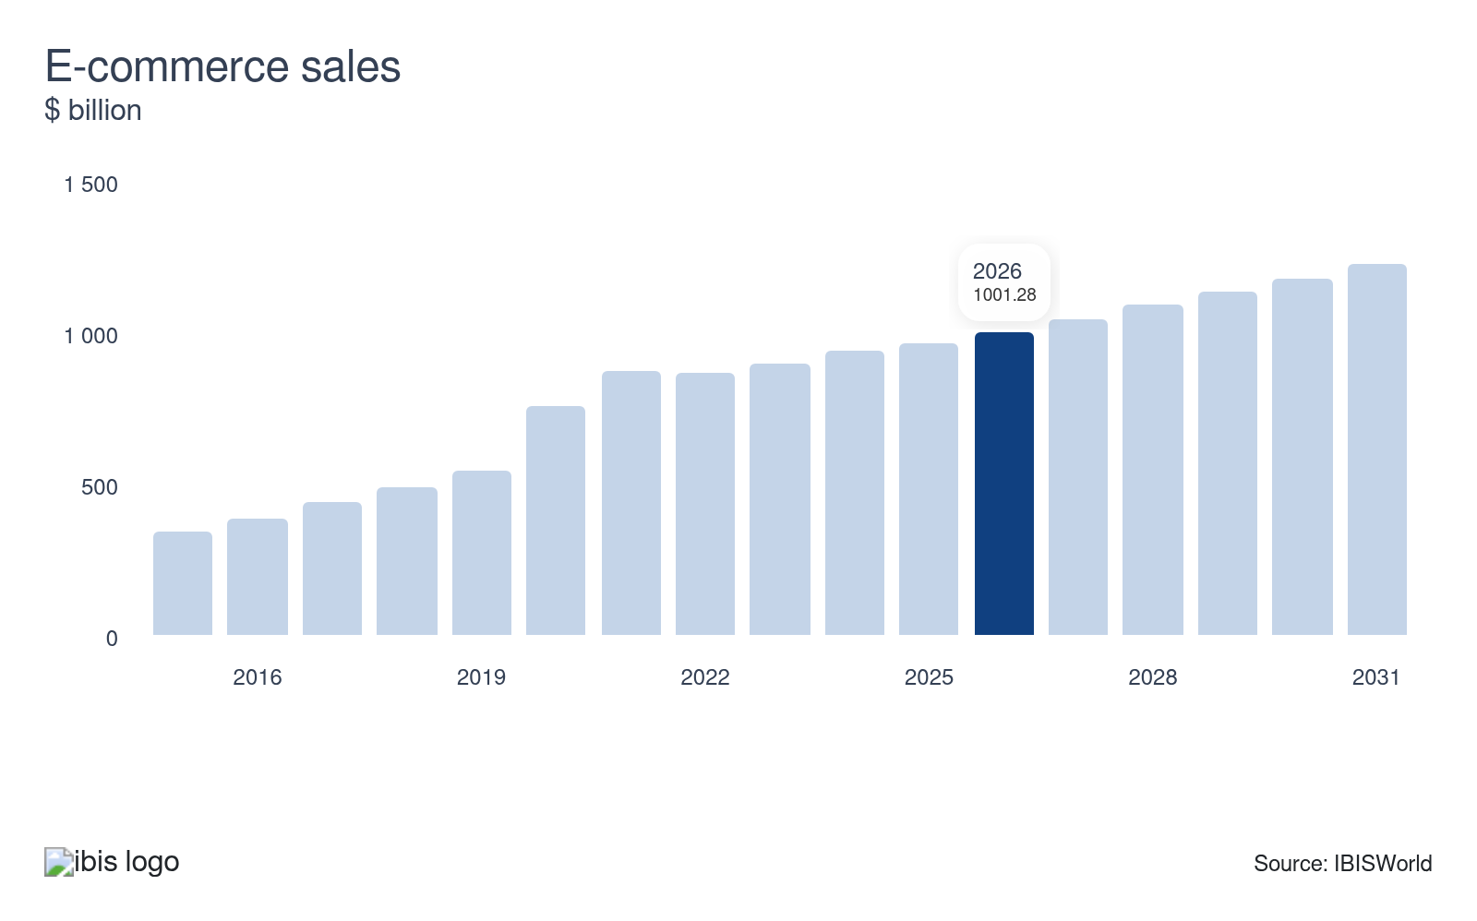
E-commerce sales have revolutionized the retail sector by broadening market reach and consumers’ access to products. As online shopping has continued to grow, traditional retailers have been pressured to innovate and adopt digital strategies. The trend toward e-commerce boosts overall sales volumes but can strain brick-and-mortar operations and resources for companies without an e-commerce strategy in place. Retailers that embrace e-commerce thrive, underscoring the growth opportunity e-commerce sales present across the sector.
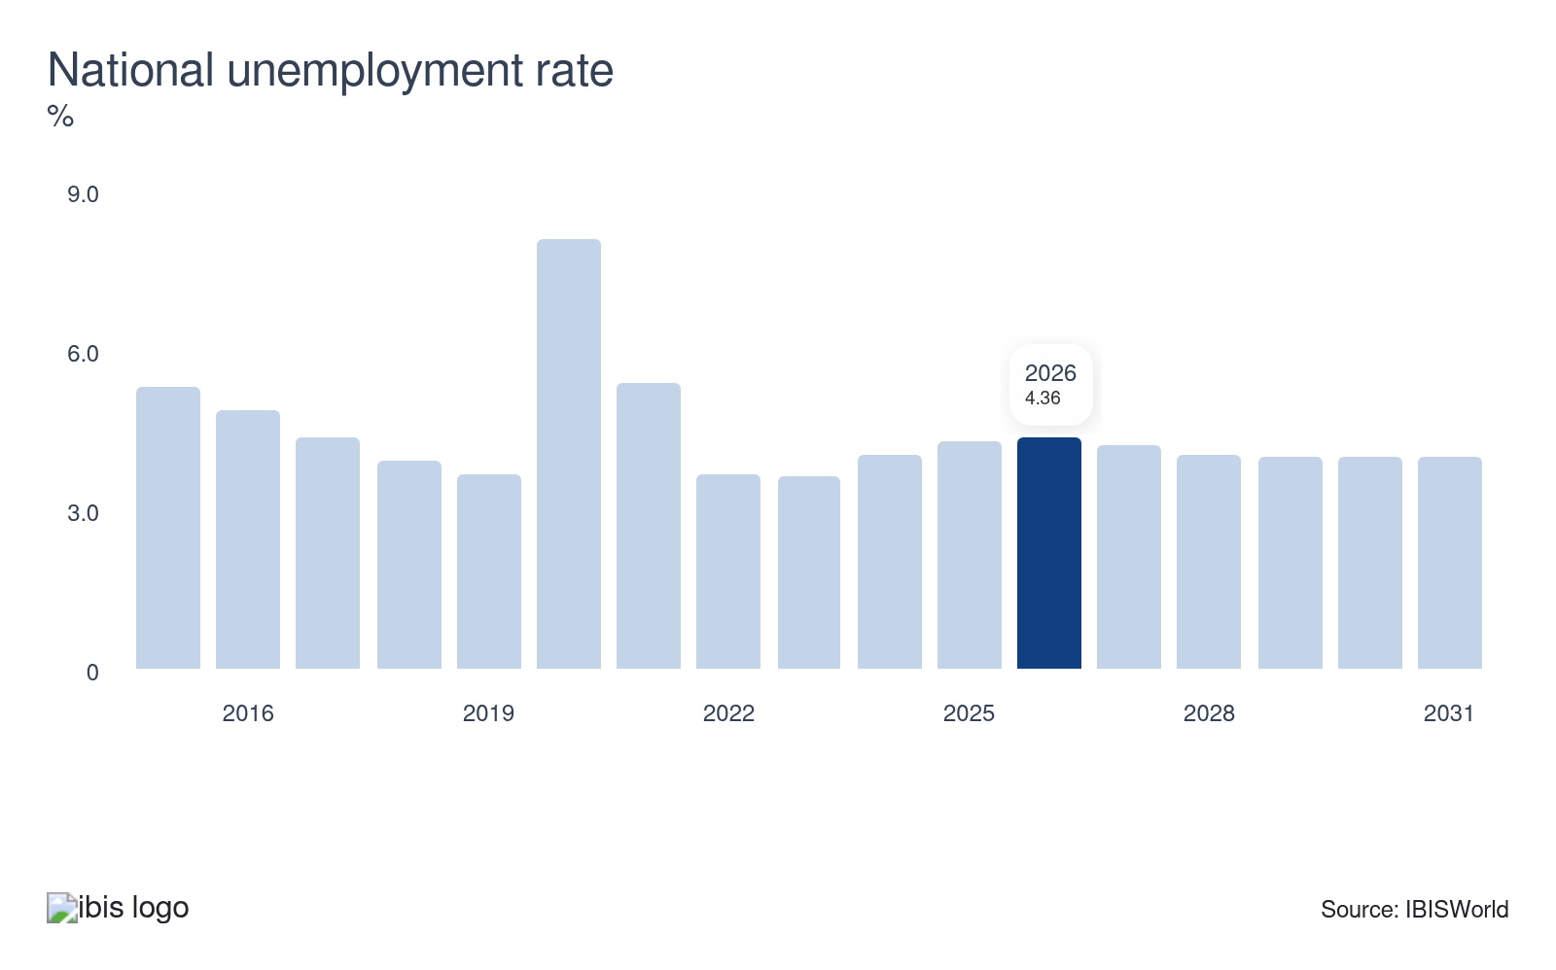
The national unemployment rate has a significant sway on consumer confidence and spending, which together determine demand for many retail products. When individuals are out of work and earning little or no income, discretionary spending typically dwindles. Conversely, when unemployment is low, more consumers are employed and have the ability to spend on retail products.

Regulation & Policy
Moderate | Steady

What regulations impact the industry?

The Fair Labor Standards Act (FLSA)
The FLSA sets federal requirements for minimum wage, overtime pay and accurate recordkeeping. For the retail trade sector, all employees working over 40 hours a week must be paid overtime at 1.5 times their regular rate. Retailers must also maintain precise time and wage records to prove compliance. Noncompliance can lead to fines, lawsuits, or Department of Labor investigations. Beyond avoiding penalties, compliance fosters an equitable workplace. As labor market scrutiny increases, retailers are aligning payroll practices more closely with federal and state labor rules to protect both profitability and employee retention.

The Occupational Safety and Health Administration (OSHA)
OSHA regulations require retail employers to provide a workplace free from hazards. In practice, this means safe store layouts with clear aisles, proper equipment safety, accessible emergency exits and adequate training for handling everything from ladders to chemicals. For the retail sector, where injuries often stem from slips, lifting, or stocking, OSHA enforcement can directly impact operational costs. Workplace incidents may trigger fines, lawsuits and higher workers’ compensation premiums. By prioritizing safety measures, retailers stay compliant and reduce turnover by signaling commitment to worker well-being, which helps foster healthier company cultures and customer-facing professionalism.

Antitrust regulations
The Sherman Antitrust Act and Clayton Antitrust Act protect fair competition and directly influence retail consolidation, pricing and supplier agreements. The Sherman Act prohibits practices such as price fixing or creating monopolies, while the Clayton Act limits mergers and acquisitions that significantly reduce industry competition. Retailers planning large-scale deals—such as big grocery chains attempting to merge—must receive approval from the Department of Justice or the Federal Trade Commission. For smaller retailers, antitrust enforcement ensures opportunities to remain competitive against dominant competitors, shaping industry structure and pricing strategies.

Consumer protection laws
Consumer protection regulations require retailers to ensure product safety, truthful labeling, ethical advertising and accessible return policies. These laws, enforced by agencies like the Federal Trade Commission and the Consumer Product Safety Commission, safeguard consumers while holding retailers accountable. In practice, violations—such as selling defective products or misleading promotions—can spark class-action suits and erode brand loyalty. By adhering to clear disclosures and safety standards, retailers strengthen consumer trust and create loyalty-driven repeat business. In a crowded market, consumer protection compliance is as much about legal risk management as it is an essential strategy for sustaining customer relationships.

Other
Retailers face oversight from agencies beyond labor and consumer safety regulators. The FDA mandates food labeling and nutrition standards for grocery and convenience retailers, while the USDA oversees meat and produce safety. The Environmental Protection Agency regulates hazardous materials, packaging waste and environmental disclosures related to products. Also, state rules add industry-specific compliance layers—alcohol sales, for instance, fall under stringent state-level liquor control boards. Retailers across states face particularly complex compliance landscapes, requiring ongoing investment in legal monitoring and training. With consumer and regulatory expectations growing around sustainability and transparency, retailers must balance traditional compliance with evolving environmental and ethical governance standards that increasingly shape competitive reputations.

Assistance
Low | Steady

What assistance is available to this industry?

Small Business Administration loans
The US Small Business Administration (SBA) is critical in supporting retail businesses through its loan programs. SBA loans often provide more favorable terms than traditional bank financing, including lower interest rates, flexible qualifications and longer repayment timelines. Retailers can direct this funding toward essential needs such as expanding inventory, upgrading store layouts, adopting new technology or covering operational expenses during slow seasons. SBA loans allow retailers to maintain stability while pursuing growth opportunities by alleviating financial pressure.

The National Retail Federation
The National Retail Federation (NRF) is an influential private sector advocate for retailers, providing essential support that combines knowledge, advocacy and community. NRF conducts in-depth research on consumer behavior, retail trends and policy impacts, equipping retailers with actionable insights to remain competitive. They organize educational offerings like training programs, certifications and professional development opportunities that strengthen workforce capabilities. Networking events and industry conferences, such as NRF's annual "Big Show," drive collaboration and innovation across the sector. Importantly, NRF's policy advocacy keeps retailers' interests visible in legislative and regulatory discussions.

Retail Industry Leaders Association
The Retail Industry Leaders Association (RILA) supports large and midsize retailers through advocacy, research and innovation strategy. The organization focuses on issues like supply chain optimization, sustainability initiatives, workforce development and public policy. By providing thought leadership, RILA helps members navigate regulatory complexities and prepare for emerging economic and social challenges. Collaboration is a hallmark of RILA's approach, offering retailers opportunities to share best practices and adopt groundbreaking solutions in areas such as omnichannel retailing, logistics technologies and ESG performance. By uniting foremost industry leaders, RILA fosters innovation while ensuring retailers have a strong collective voice in shaping the future of commerce.

9. Financial Benchmarks
https://my.ibisworld.com/us/en/industry/44-45/financial-benchmarks
Profit Margin  9.2 %  ↑ Higher than sector | Average Wage  $35,969  ↑ Higher than sector | Largest Cost  Purchases  61.5% of Revenue

Key Takeaways
- Retailers are getting smarter with their inventory purchases through tech. Using automated systems and AI-driven forecasting optimizes inventory management, which cuts down on overstock and reduces storage costs, raising overall efficiency.
- E-commerce and automation are modernizing the retail workforce. With more sales happening online, stores need fewer employees, allowing them to save on wages and focus on enhancing inventory management and order fulfillment.
- Digital strategies keep marketing and rent costs in check for retailers. They’re harnessing data analytics and utilizing influencer collaborations to reach consumers effectively without breaking the bank, while smaller storefronts stabilize rent costs and thereby boost profit.

Cost Structure
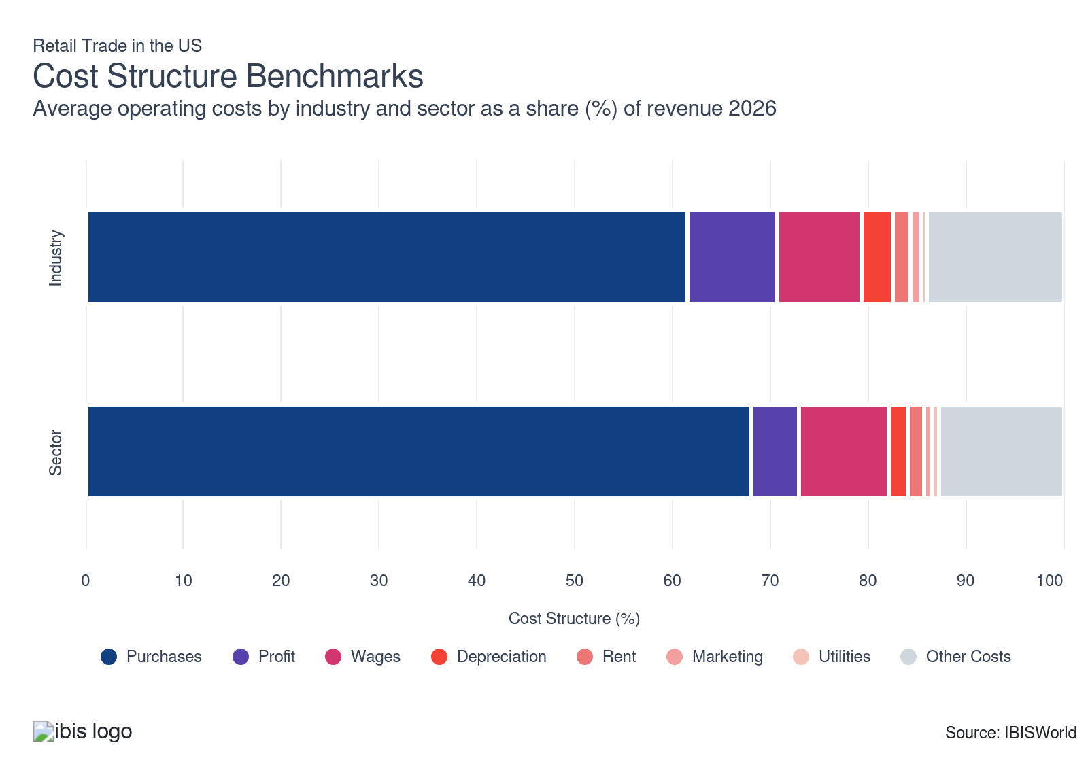
Chart displays current year only in the PDF version of this report. You can view and download chart for all other years associated with this industry on my.ibisworld.com.

What trends impact industry costs?

Tech-driven inventory strategies help manage purchase costs despite inflation swings
- Retailers rely on constant replenishment of diverse, short-cycle inventories, making purchases their largest and most sensitive operating cost. Automated systems and AI-driven demand forecasting now help manage stock levels precisely, reducing overbuying, waste and associated carrying costs.
- While suppliers historically held pricing power, easing inflation has stabilized product prices, enabling retailers to plan purchases more predictably. As a result, purchase costs dipped in 2022 and 2023 and remain relatively flat as a share of revenue.
- Retailers increasingly use long-term supplier contracts and improved logistics to lock in favorable rates and offset future cost volatility, reinforcing the overall stability in purchasing expenditures.

Automation and omnichannel shifts keep retail wage costs steady
- Retailers depend on large, flexible workforces for sales, stocking and fulfillment, but automation has steadily reduced manual labor needs. Self-checkout kiosks, e-commerce platforms and micro-fulfillment systems have cut demand for in-store staff, slightly lowering overall wage expenses.
- As omnichannel operations expanded, labor shifted from customer-facing roles to more automated, back-end fulfillment tasks. Tools such as robotics, pick-to-light and routing software boosted worker productivity, allowing average pay to rise in line with efficiency gains. As omnichannel operations expanded, labor shifted from customer-facing roles to more automated, back-end fulfillment tasks. Tools such as robotics, pick-to-light and routing software boosted worker productivity, allowing average pay to rise in line with efficiency gains.

Cooling inflation and smarter pricing stabilize retail profit
- The sector's profit dipped by about 3.0% in 2021 as online price matching and marketplace competition capped markups while inflation and rate hikes lifted procurement and financing costs. Retailers selling essential products like groceries can more easily pass along rising costs to customers, but stores selling discretionary items find it harder to incentivize consumers to pay higher prices rather than delay purchases or seek cheaper alternatives.
- As inflation cooled and real incomes improved, retailers have leaned on private-label mix, targeted promotions and loyalty-driven personalization to lift and stabilize profit. Dynamic pricing and retail media monetization improved contribution margins, helping profit's revenue share flatten rather than continue contracting despite ongoing competitive intensity.

Faster tech cycles nudge depreciation higher
- Depreciation costs accrue from store fit-outs, POS systems, automation and IT. Its revenue share has risen slightly as chains refresh kiosks, smart shelving scanners and other fulfillment tech on shorter cycles to support omnichannel speed and in-store digitization.
- Shorter asset lives for digital screens, edge devices and automated systems accelerate expense recognition, lifting noncash costs per sales dollar even as capex improves labor productivity and shrink control. Modular, upgradable technology systems and flexible leasing options allow retailers to manage their depreciation expenses more variably.

Smaller footprints and flexible leases keep rent share steady
- The popularity of online shopping has reduced the need for vast physical storefronts, helping keep rent costs steady. Many retailers now favor smaller, strategically located stores that serve as showrooms or pickup points. Relocations to high-traffic corridors increased sales per square foot, offsetting prime-location rate growth and preventing rent from expanding as a share of revenue.
- Stable rent costs enable retailers to invest more in digital platforms and customer experiences, enhancing overall sector performance. Adopting flexible store formats or negotiating lease terms that reflect an omnichannel approach will reduce the rent burden.

Targeted digital marketing maximizes retail advertising budgets’ impact
- Retail subsectors tailor their strategies to their consumers. For example, grocery chains are utilizing data analytics to send personalized promotions to apps and shopping cart displays, while fashion retailers are more likely to emphasize influencer collaborations on digital platforms to reach specific demographics.
- Marketing costs have been steady at around 1.0% of sector revenue throughout the period, despite rising competitive pressures. Digital marketing’s precise targeting and engagement have helped retailers achieve greater reach without the hefty costs of traditional media. AI-driven technologies can help retailers execute more tailored campaigns to optimize marketing return on investment.

Energy-efficient and renewable energy systems reduce exposure to volatile energy prices, keeping utility costs low
- Adopting energy-efficient technologies in retail spaces, including smart HVAC systems and advanced LED lighting, has helped keep retailers’ energy costs steady by reducing consumption amid volatility in energy prices. In addition, by integrating renewable energy solutions such as solar panels, retailers reduce their reliance on traditional, more costly energy sources.
- Low utility costs, which represent the smallest portion of sector revenue during the current period, support profit and improved sector performance. Embracing sustainable solutions, such as smart energy management systems and interconnected energy monitoring via the Internet of Things, mitigates utility costs.
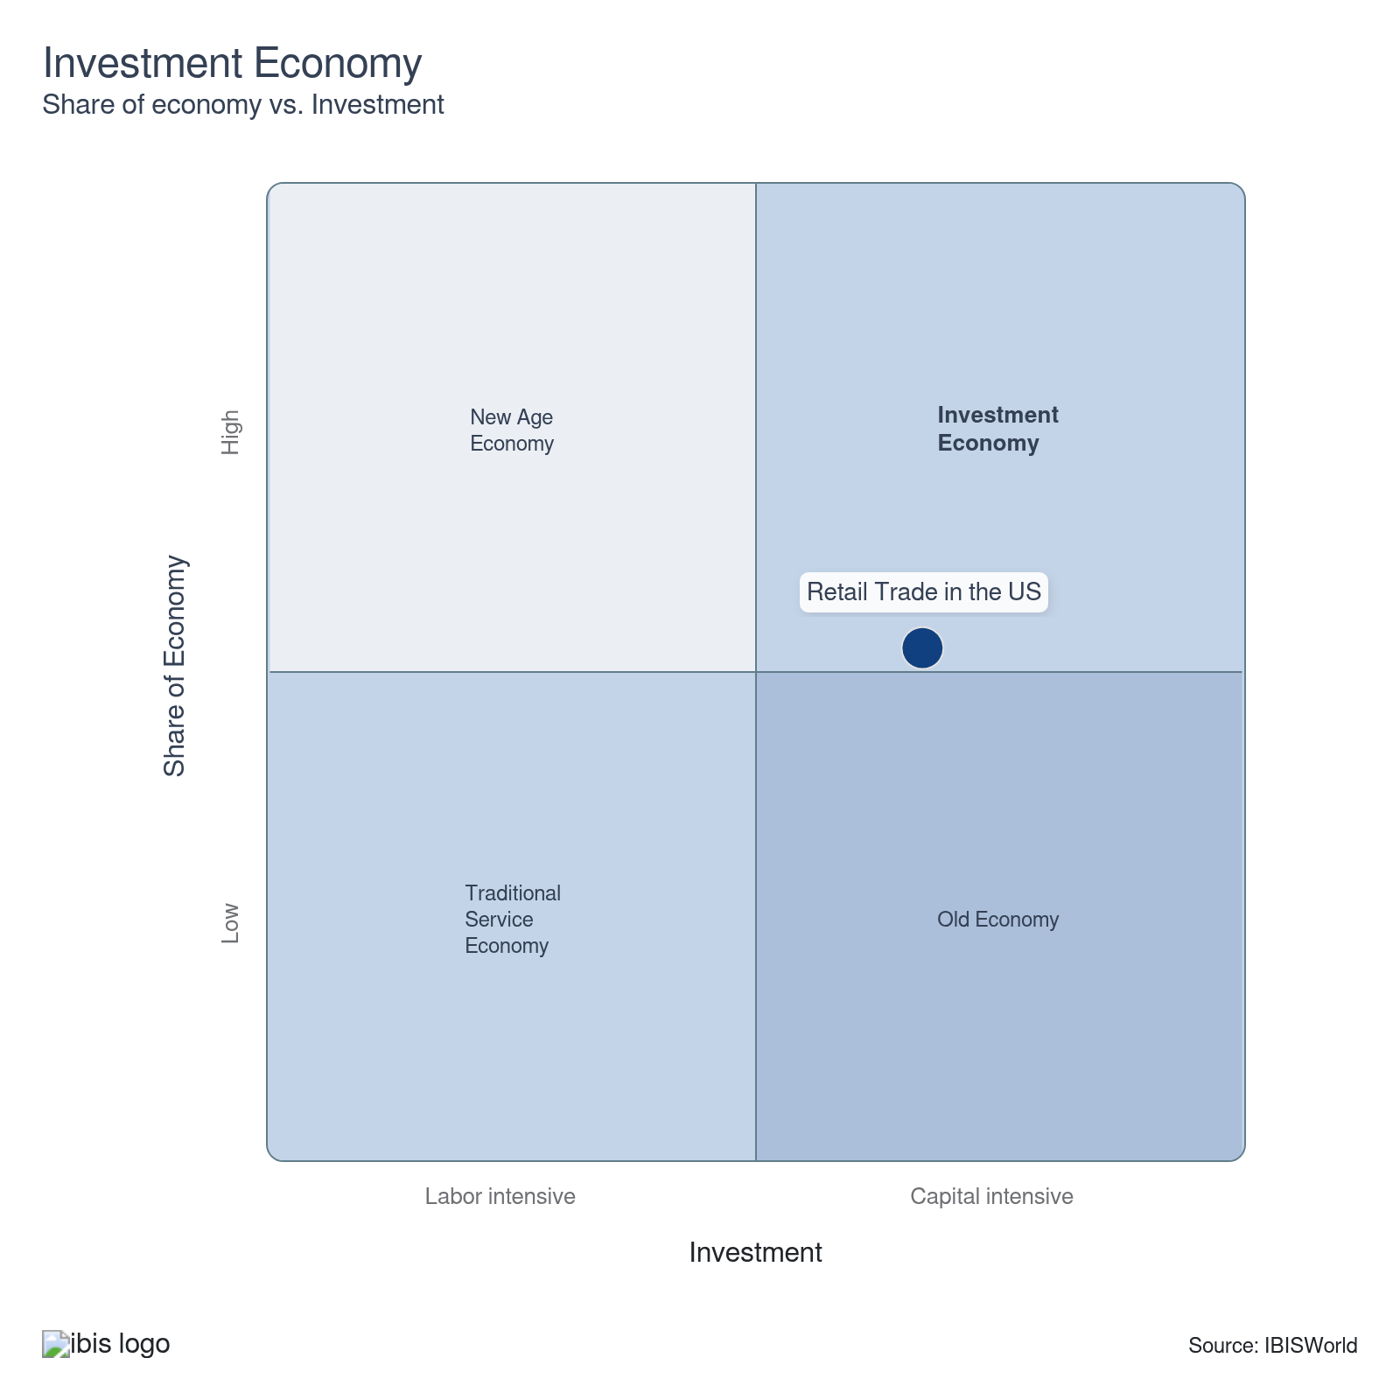

Key Ratios
Year | Revenue per Employee  ($) | Revenue per Enterprise  ($ Million) | Employees per Estab.  (Units) | Employees per Enterprise  (Units) | Average Wage  ($) | Wages/ Revenue  (%) | Estab. per Enterprise  (Units) | IVA/ Revenue  (%)
2005 | 335,171 | 2.2 | 5.7 | 6.6 | 33,045 | 9.9 | 1.1 | 24.6
2006 | 333,664 | 2.3 | 5.9 | 6.8 | 33,106 | 9.9 | 1.2 | 26.2
2007 | 332,953 | 2.2 | 5.7 | 6.6 | 32,639 | 9.8 | 1.2 | 26.5
2008 | 326,557 | 2.2 | 5.9 | 6.8 | 31,942 | 9.8 | 1.2 | 26.8
2009 | 313,120 | 2.1 | 5.7 | 6.7 | 32,123 | 10.3 | 1.2 | 24.1
2010 | 333,435 | 2.2 | 5.6 | 6.6 | 32,667 | 9.8 | 1.2 | 24.1
2011 | 346,365 | 2.3 | 5.7 | 6.6 | 32,550 | 9.4 | 1.2 | 23.2
2012 | 353,127 | 2.3 | 5.6 | 6.5 | 32,169 | 9.1 | 1.2 | 23.7
2013 | 355,490 | 2.4 | 5.7 | 6.6 | 32,051 | 9.0 | 1.2 | 22.6
2014 | 355,180 | 2.4 | 5.7 | 6.6 | 32,299 | 9.1 | 1.2 | 26.1
2015 | 351,150 | 2.4 | 5.8 | 6.7 | 33,029 | 9.4 | 1.2 | 30.4
2016 | 351,308 | 2.4 | 5.8 | 6.8 | 32,902 | 9.4 | 1.2 | 26.3
2017 | 362,412 | 2.4 | 5.6 | 6.5 | 33,134 | 9.1 | 1.2 | 30.1
2018 | 369,693 | 2.4 | 5.6 | 6.5 | 33,348 | 9.0 | 1.1 | 30.3
2019 | 373,827 | 2.4 | 5.7 | 6.5 | 33,730 | 9.0 | 1.1 | 24.0
2020 | 374,320 | 2.3 | 5.5 | 6.3 | 33,797 | 9.0 | 1.1 | 24.0
2021 | 422,941 | 2.5 | 5.3 | 5.9 | 36,388 | 8.6 | 1.1 | 19.6
2022 | 422,104 | 2.7 | 5.6 | 6.4 | 36,353 | 8.6 | 1.1 | 20.6
2023 | 411,903 | 2.6 | 5.6 | 6.4 | 35,983 | 8.7 | 1.1 | 21.6
2024 | 411,190 | 2.6 | 5.6 | 6.4 | 35,972 | 8.7 | 1.1 | 21.4
2025 | 410,480 | 2.6 | 5.6 | 6.4 | 35,959 | 8.8 | 1.1 | 21.2
2026 | 411,092 | 2.6 | 5.6 | 6.4 | 35,969 | 8.7 | 1.1 | 21.1
2027 | 413,921 | 2.7 | 5.6 | 6.4 | 36,019 | 8.7 | 1.1 | 21.1
2028 | 416,365 | 2.7 | 5.7 | 6.5 | 36,061 | 8.7 | 1.1 | 21.1
2029 | 418,436 | 2.7 | 5.7 | 6.5 | 36,097 | 8.6 | 1.1 | 21.2
2030 | 419,795 | 2.8 | 5.7 | 6.6 | 36,121 | 8.6 | 1.1 | 21.2
2031 | 420,260 | 2.8 | 5.7 | 6.6 | 36,129 | 8.6 | 1.1 | 21.2
2032 | 420,539 | 2.8 | 5.8 | 6.6 | 36,133 | 8.6 | 1.1 | 21.2
*Figures are inflation adjusted to 2026
*Figures are inflation adjusted to 2026

10. Key Statistics
https://my.ibisworld.com/us/en/industry/44-45/key-statistics

Industry Data

Values
Year | Revenue  ($ Million) | IVA  ($ Million) | Estab.  (Units) | Enterprises  (Units) | Employment  (Units) | Wages  ($ Million)
2005 | 5,771,574.0 | 1,418,568.4 | 3,004,322 | 2,618,055 | 17,219,787 | 569,036.1
2006 | 5,880,985.9 | 1,540,377.9 | 2,977,930 | 2,583,188 | 17,625,477 | 583,514.6
2007 | 5,906,412.6 | 1,563,614.2 | 3,103,205 | 2,692,523 | 17,739,504 | 579,007.8
2008 | 5,711,548.7 | 1,528,499.0 | 2,976,368 | 2,568,562 | 17,490,182 | 558,673.1
2009 | 5,206,875.6 | 1,252,641.6 | 2,902,869 | 2,496,781 | 16,628,991 | 534,174.1
2010 | 5,441,075.9 | 1,312,947.7 | 2,889,604 | 2,485,678 | 16,318,245 | 533,060.8
2011 | 5,731,151.0 | 1,331,979.5 | 2,910,935 | 2,502,286 | 16,546,556 | 538,592.3
2012 | 5,901,844.8 | 1,397,429.1 | 2,968,989 | 2,555,896 | 16,713,105 | 537,635.8
2013 | 6,018,435.1 | 1,361,876.7 | 2,970,213 | 2,558,565 | 16,929,959 | 542,619.8
2014 | 6,156,452.2 | 1,607,984.1 | 3,026,050 | 2,611,528 | 17,333,314 | 559,843.2
2015 | 6,211,749.0 | 1,890,869.0 | 3,055,762 | 2,637,971 | 17,689,720 | 584,280.8
2016 | 6,313,548.7 | 1,661,666.5 | 3,072,765 | 2,654,666 | 17,971,562 | 591,309.2
2017 | 6,450,676.4 | 1,944,627.5 | 3,157,908 | 2,741,386 | 17,799,267 | 589,766.2
2018 | 6,575,567.6 | 1,993,311.6 | 3,153,574 | 2,746,219 | 17,786,546 | 593,141.9
2019 | 6,651,628.0 | 1,598,190.0 | 3,144,976 | 2,736,579 | 17,793,309 | 600,172.2
2020 | 6,762,236.2 | 1,625,332.5 | 3,293,734 | 2,889,671 | 18,065,378 | 610,548.5
2021 | 7,570,902.6 | 1,486,693.8 | 3,406,859 | 3,015,730 | 17,900,610 | 651,364.4
2022 | 7,637,035.1 | 1,575,313.3 | 3,216,212 | 2,815,726 | 18,092,760 | 657,720.4
2023 | 7,516,302.2 | 1,622,373.7 | 3,244,915 | 2,842,430 | 18,247,749 | 656,614.3
2024 | 7,509,044.4 | 1,605,220.0 | 3,259,818 | 2,857,170 | 18,261,732 | 656,905.1
2025 | 7,499,890.6 | 1,588,738.0 | 3,268,028 | 2,865,531 | 18,271,018 | 657,015.6
2026 | 7,569,488.8 | 1,600,349.1 | 3,291,127 | 2,885,697 | 18,413,114 | 662,304.8
2027 | 7,778,712.3 | 1,643,190.4 | 3,341,278 | 2,927,658 | 18,792,760 | 676,890.5
2028 | 7,959,401.7 | 1,678,302.4 | 3,377,114 | 2,956,608 | 19,116,387 | 689,360.4
2029 | 8,129,189.4 | 1,720,861.3 | 3,403,935 | 2,977,012 | 19,427,575 | 701,278.9
2030 | 8,289,997.1 | 1,761,498.3 | 3,447,502 | 3,013,685 | 19,747,709 | 713,298.1
2031 | 8,405,016.7 | 1,781,813.0 | 3,484,626 | 3,045,423 | 19,999,572 | 722,555.4
2032 | 8,521,632.1 | 1,804,235.9 | 3,523,995 | 3,079,180 | 20,263,615 | 732,192.0

*Figures are inflation adjusted to 2026

Annual Change
Year | Revenue  % | IVA  % | Estab.  % | Enterprises  % | Employment  % | Wages  %
2005 | N/A | N/A | N/A | N/A | N/A | N/A
2006 | 1.9 | 8.6 | -0.9 | -1.3 | 2.4 | 2.5
2007 | 0.4 | 1.5 | 4.2 | 4.2 | 0.6 | -0.8
2008 | -3.3 | -2.2 | -4.1 | -4.6 | -1.4 | -3.5
2009 | -8.8 | -18.0 | -2.5 | -2.8 | -4.9 | -4.4
2010 | 4.5 | 4.8 | -0.5 | -0.4 | -1.9 | -0.2
2011 | 5.3 | 1.4 | 0.7 | 0.7 | 1.4 | 1.0
2012 | 3.0 | 4.9 | 2.0 | 2.1 | 1.0 | -0.2
2013 | 2.0 | -2.5 | 0.0 | 0.1 | 1.3 | 0.9
2014 | 2.3 | 18.1 | 1.9 | 2.1 | 2.4 | 3.2
2015 | 0.9 | 17.6 | 1.0 | 1.0 | 2.1 | 4.4
2016 | 1.6 | -12.1 | 0.6 | 0.6 | 1.6 | 1.2
2017 | 2.2 | 17.0 | 2.8 | 3.3 | -1.0 | -0.3
2018 | 1.9 | 2.5 | -0.1 | 0.2 | -0.1 | 0.6
2019 | 1.2 | -19.8 | -0.3 | -0.4 | 0.0 | 1.2
2020 | 1.7 | 1.7 | 4.7 | 5.6 | 1.5 | 1.7
2021 | 12.0 | -8.5 | 3.4 | 4.4 | -0.9 | 6.7
2022 | 0.9 | 6.0 | -5.6 | -6.6 | 1.1 | 1.0
2023 | -1.6 | 3.0 | 0.9 | 0.9 | 0.9 | -0.2
2024 | -0.1 | -1.1 | 0.5 | 0.5 | 0.1 | 0.0
2025 | -0.1 | -1.0 | 0.3 | 0.3 | 0.1 | 0.0
2026 | 0.9 | 0.7 | 0.7 | 0.7 | 0.8 | 0.8
2027 | 2.8 | 2.7 | 1.5 | 1.5 | 2.1 | 2.2
2028 | 2.3 | 2.1 | 1.1 | 1.0 | 1.7 | 1.8
2029 | 2.1 | 2.5 | 0.8 | 0.7 | 1.6 | 1.7
2030 | 2.0 | 2.4 | 1.3 | 1.2 | 1.6 | 1.7
2031 | 1.4 | 1.2 | 1.1 | 1.1 | 1.3 | 1.3
2032 | 1.4 | 1.3 | 1.1 | 1.1 | 1.3 | 1.3

*Figures are inflation adjusted to 2026

DISCLAIMER
This product has been supplied by IBISWorld Inc. (‘IBISWorld’) solely for use by its authorized licenses strictly in accordance with their license agreements with IBISWorld. IBISWorld makes no representation to any other person with regard to the completeness or accuracy of the data or information contained herein, and it accepts no responsibility and disclaims all liability (save for liability which cannot be lawfully disclaimed) for loss or damage whatsoever suffered or incurred by any other person resulting from the use of, or reliance upon, the data or information contained herein. Copyright in this publication is owned by IBISWorld Inc. The publication is sold on the basis that the purchaser agrees not to copy the material contained within it for other than the purchasers own purposes. In the event that the purchaser uses or quotes from the material in this publication – in papers, reports, or opinions prepared for any other person – it is agreed that it will be sourced to: IBISWorld Inc.

